Lady Liberty Academy Charter School

2nd Grade Year at a Glance in Mathematics

By Mrs. Rymer

*TRIMESTER 1* (September-December)
First 2 weeks of school-  Math Review  18-6= 7+8= 1+2+3=6  5  + 2  4 | - Addition and Subtraction math facts from 0-20, adding and subtracting 2 digits to 1 digit (18-5=13), Mental Math and 3 digit alignment or problems should be given in both vertical or horizontal forms)
Place Value Numbers with 2 digits-> tens and ones  25= 2 tens and 5 ones  Standard Form: 25  Expanded form: 20+5  Word form: Twenty-five  Model form:  25>19  tens ones  2 5 | - How many tens and how many ones are in a number?  - Showing what a ten is by using base ten rods and ones through using unit cubes.  - Presenting place value in various forms such as: expanded, standard, word, and model forms.  - Compare 2 digit numbers using <,>, or =.
2 digit addition and subtraction without regrouping.  12+24=  Tens Ones  13  +22  *Ms. Rymer has 12 bubbles and Ms. Levin has 14 bubbles, how many do they have altogether? | - Students can add up to 2-digit numbers.(In forms of Horizontal, vertical, and word form problems without regrouping)  - Students can subtract 2 digit numbers.(In forms of Horizontal, vertical, and word form problems without regrouping)  - Students are well aware of the place value of tens and ones between 2 digit numbers while adding and subtracting.
2 digit addition and subtraction with regrouping.  25-19=  Tens Ones  (3) 4 0 (10)  - 3 2  *Students should be able to recognize quickly math problems that need to be regrouped.  Can we regroup? Yes or No  12-19= (Yes because the 2 in the ones is less than 9). | - Students can add up to 2-digit numbers.(In forms of Horizontal, vertical, and word form problems with regrouping)  - Students can subtract 2 digit numbers.(In forms of Horizontal, vertical, and word form problems with regrouping)  - Students are well aware of the place value of tens and ones between 2 digit numbers while adding and subtracting.
Place Value up to 1,000  *Students must practice counting by 100’s –  100,200,300,400,500,600,  700,800,900,1,000!  Standard Form: 123  Word form: One hundred twenty-three  Expanded Form: 100+20+3  Model Form:  Hundreds Tens Ones  1 2 3  123<134  123=1 hundred, 2 tens, 3 ones | - Students will be able to understand and use the hundreds, tens, and ones place value.  - Students will be able to show that 10 bundles of tens are called a “hundred.”  - Students will be able to count to 1,000 by 1’s, 5’s, 10’s and 100’s.  - Students will be able to write numbers in 100’s in various ways/  - Students can compare three digit numbers using <,>, and =.  - Students must be able to distinguish place value modes cube=1,000 units,  Flat=100 units, rod=10 units, a unit cube=1 unit.
3 Digit addition and subtraction without regrouping.  312+224= H T O H-Hundreds  423 T-Tens  -422 O-Ones | - Students can add up to 3-digit numbers.(In forms of Horizontal, vertical, and word form problems without regrouping)  - Students can subtract 3 digit numbers.(In forms of Horizontal, vertical, and word form problems without regrouping)  - Students are well aware of the place value of hundred, tens, and ones between 3 digit numbers while adding and subtracting.
3 Digit addition and subtraction with regrouping  319+224= H T O H-Hundreds  5 13 T-Tens  -4 22 O-Ones  *Students should be able to recognize quickly math problems that need to be regrouped.  Can we regroup? Yes or No  (Yes, because we cannot subtract 1-2 in the tens place. 1 is < than 2 and numbers on top that are less than the numbers on the bottom are a sign of regrouping and borrowing from our next number neighbors.) | - Students can add up to 3-digit numbers.(In forms of Horizontal, vertical, and word form problems with regrouping)  - Students can subtract 3 digit numbers.(In forms of Horizontal, vertical, and word form problems with regrouping)  - Students are well aware of the place value of hundred, tens, and ones between 3 digit numbers while adding and subtracting.

Trimester 2 (January-March)

Estimation and Rounding 2 digit numbers.  *Round to nearest tens-  4550  43 40  +25 +30  Rounding Rules  - Find the number, look next door.  - 4 or less, just ignore!  - 5 or greater, add 1 more!  - Be a hero, everything after, write a zero! | - Students will be able to round 2 digit numbers to the nearest tens.  - Students will be able to round 2 digit numbers in order to add or subtract to receive an estimated answer.  - Students will be able to utilize rounding as a strategy to check their answers and work.
Estimation and Rounding 3 digit numbers.  *Round to nearest tens.  345350  *Round to nearest hundred.  345300  *Students will also round and estimate numbers for addition and subtraction with 3 digit numbers. | - Students will be able to round 3 digit numbers to the nearest tens and hundreds.  - Students will be able to round 3 digit numbers in order to add or subtract to receive an estimated answer.  - Students will be able to utilize rounding as a strategy to check their answers and work.
Adding and Subtracting 1 and 2 Step Word Problems  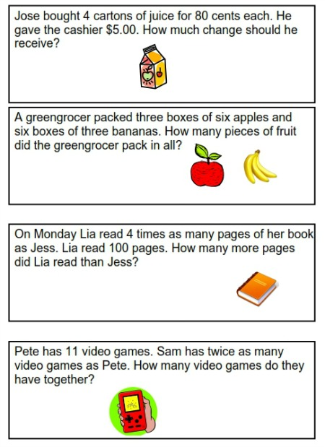 | - Recognizing key words/clues to choose a specific math strategy to solve.  - Reading the word problem carefully and understanding the question the problem is asking.  - Identifying a math strategy such as: addition, subtraction, multiplication, division, etc.  - Choosing various strategies such as: drawing illustrations, visualizing, using numbers, tally marks, etc.  - Ensuring to solve the problem in the sequence of what is stating and being able to support an answer their evidence of a math strategy.
Money  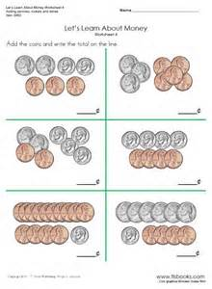 | • Recognize bills and coins and their respective values  • Use the decimal point to separate dollars and cents  • Exchange dollars for cents and vice versa  • Compare amounts of money using tables  • Use bar models to solve real-world problems involving addition and  Subtraction of money.
Metric Measurement  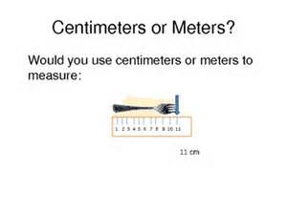 | • Measure and compare how long and how tall things are using metric  measurements (centimeter and meter)  • Draw a line of a given length  • Use model drawing to solve real-world measurement problems.
Customary Measurement  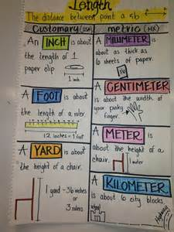 | • Use a ruler to measure, compare and estimate lengths of objects in  customary units of measurement (feet and inches)  • Solve one and two-step problems involving length.
Odd and Even Numbers  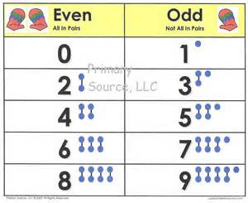 | - Differentiating numbers that are even and odd through number recognition.  - Acknowledging that even numbers are grouped as equal and odd numbers are unequal groups.  - Adding 2 even numbers, you receive an even number. Adding 2 odd numbers, you receive an even number. Adding an even and odd number, you receive an odd number.

Trimester 3 (April-June)

Multiplication tables of 2, 5, 10  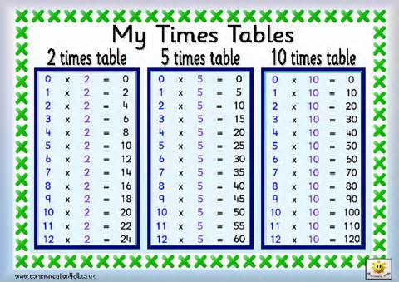 | • Skip counting by 2, 5 and 10  • Use dot paper as concrete representation of multiplication facts of 2, 5 and 10 to form arrays.  • Identify related multiplication facts  • Divide using related multiplication facts.  • Learn that multiplication involves the concept of equal groups  • Create multiplication stories and sentences about pictures  • Use equal groups and repeated addition to multiply.
Multiplication Tables of 3, 4  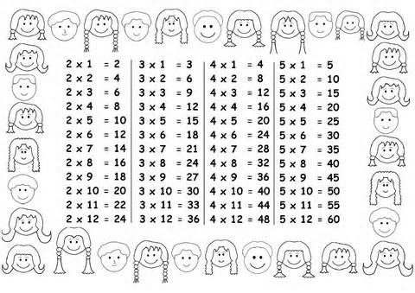 | • Use skip-counting and dot paper strategies as concrete representations  To learn the multiplication facts for 3 and 4.  Use dot paper as concrete representation of multiplication facts of 3 and 4 to form arrays.  • Use the inverse relationship of multiplication and division to write division sentences from related multiplication sentences.  • Learn that multiplication involves the concept of equal groups  • Create multiplication stories and sentences about pictures  • Use equal groups and repeated addition to multiply.
Division  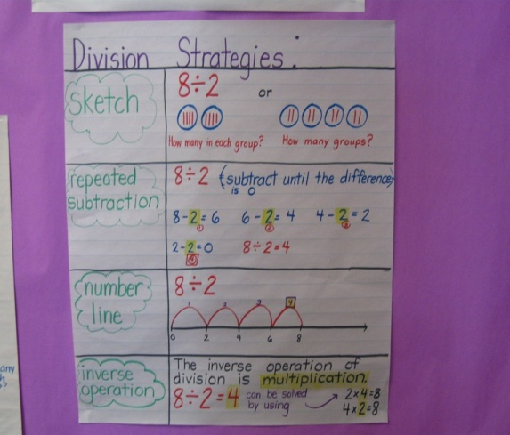 | • Divide to share equally.  • Divide by repeated subtraction of equal groups.  - Draw a picture  - Repeated Subtraction  - Number line  - Inverse Multiplication fact operation
Fractions  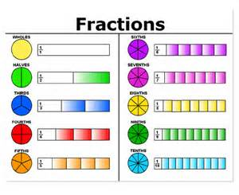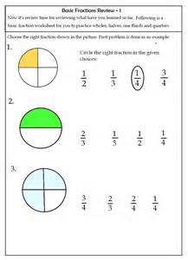 | - Dividing shapes into equal parts.  - Recognizing the numerator from the denominator.  - Read, write and identify unit fractions for halves, thirds and fourths  - Partitioning shapes into equal parts independently.  - Adding fractions with common denominators.
Time  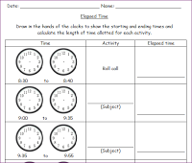 | • Show and tell time in hours and minutes  • Use A.M. and P.M. to show morning, afternoon or night  • Order events by time and determine elapsed time (hour and half hour).
Picture and Bar Graphs  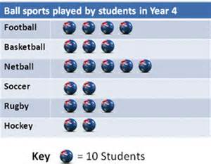 | • Read, analyze and interpret picture graphs.  • Make picture graphs and solve real-world problems using picture graphs.
Shapes and Lines  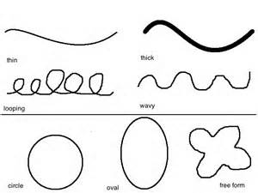 | • Recognize, draw, identify and describe parts of lines and curves  • Identify, classify and count flat and curved surfaces  • Identify solids that can stack, slide and/or roll
2-D & 3-D Shapes and Patterns  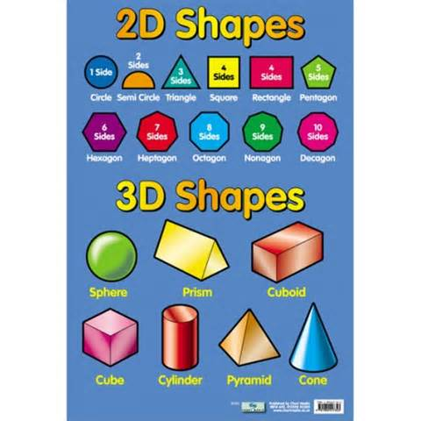 | • Identify, classify and combine plane and solid shapes  • Draw shapes and figures on dot paper and square grid paper  • Build models using solid shapes  • Identify, describe, extend and create patterns using different sizes,  shapes, colors and positions

