Lady Liberty Academy

Fifth Grade Curriculum

Language Arts

Revised 2014

Introduction
Lady Liberty Academy's Common Core Standards curriculum is built upon interdisciplinary thematic units for each 14-week trimester. Within each theme are essential "Big Idea" questions that are geared to foster a love of learning and a desire to understand the world around us. Thematic units also offer an academically rigorous and effective method of approaching the Common Core Standards. Multiple novels, children's magazines, nonfiction texts, math manipulatives, and iPads make up the majority of materials in the classrooms. Our curricula is “living”, which means it is continuously refined to meet the needs of students by being relevant and engaging.

Lady Liberty Academy recognizes that all students learn at different rates; therefore, teachers need to meet students at their current academic level, whether it's below grade level or above. The Vertical Progression Guide document outlines each standard as it develops in complexity through the grade levels. Teachers are expected to use the Vertical Progression Guide to fill in gaps in learning from previous grades, and to challenge advanced students who are ready for above-grade-level assignments. A vertical progression guideline is located at the end of each grade level curriculum.

All of our curriculum units may be found online through the Departments tab on our school website at www.LLACS.org.

5th Grade Yearly Overview

 | Trimester 1 | Trimester 2 | Trimester 3
Reading Standards | RI 5.1, RL5.2,RL 5.3, RI5.4, RL5.5, RL5.6 RL5.7, RI5.9 | RL 5.1, RI5.2,RI 5.3, RL5.4, RI5.5, RI5.6 RI5.7, RI5.8, RL5.9 | RL 5.1, RI 5.1, RI5.2,RL 5.3, RL5.4,RI 5.4 RI 5.5, RI5.7, RI 5.9
Writing Standards | W5.3, W5.4, W5.5, W5.6, W5.7, W5.8, W5.9, W5.10 | W5.2, W5.4, W5.5, W5.6, W5.7, W5.8, W5.9, W5.10 | W5.1, W5.4, W5.5, W5.6, W5.7, W5.8, W5.9, W5.10
Speaking and Listening | SL5.1, SL5.2, SL5.6 | SL5.1, SL5.2, SL5.6 | SL5.1, SL5.2, SL5.5
Language Standards | L5.1, L5.2 | L5.3, L5.4 | L5.5, L5.6
Themes | “The Movement”; “Out of the Shadows” | “Out of the Shadows”; “End Apartheid” | “End Apartheid”; “Deception”
Text | THE WATSONS GO TO BIRMINGHAM; AMONG THE HIDDEN | AMONG THE HIDDEN; KAFFIR Boy | KAFFIR Boy; Nothing But The Truth
Writing | NARRATIVE/EXPOSITORY | EXPOSITORY/PERSUASIVE | PERSUASIVE/SPIRAL
Test Dates | SEPT 19TH  OCTOBER 3RD  OCTOBER 17TH  OCTOBER 30TH  NOVEMBER 14TH | DECEMEBER 5TH  DECEMBER 19TH  JANUARY 16TH  JANUARY 30TH  FEBRAURY 13TH  FEBRUARY 27TH  MARCH 13TH | MARCH 27TH  APRIL 10TH  APRIL 24TH  MAY 1ST  MAY 15TH  MAY 29TH  JUNE 12TH

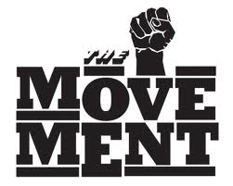
5.1 The Movement
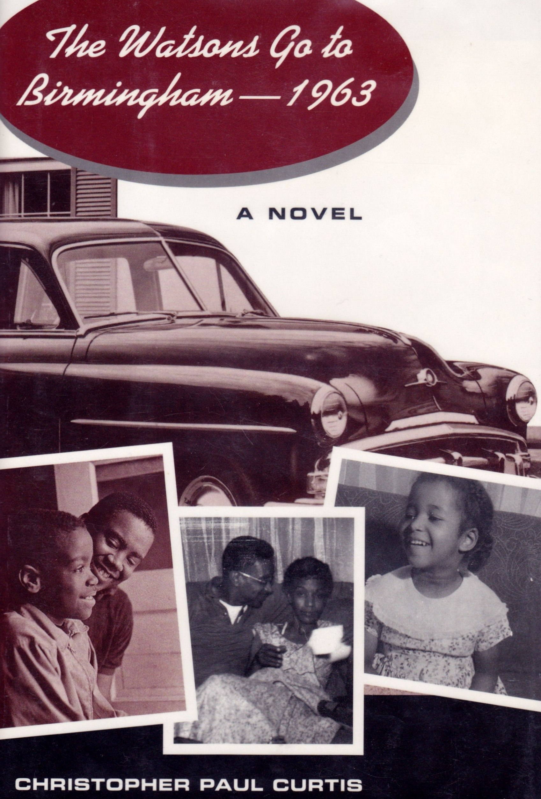

This 14-week unit focuses on the many ways the Civil Rights Movement impacts our society today and in current events around the world. Students will read and analyze the novel The Watsons Go To Birmingham by Christopher Paul Curtis to build knowledge and understanding about the Civil Right Movement in order to critically analyze it from today’s perspectives.

Essential Question
- In what ways has the “The Movement” impacted the United States in the way Civil Rights Leaders thought it would have by the year 2014? In what ways has it not?

Building Background Knowledge
- http://www.youtube.com/watch?v=oROsbaxWH0M Change the world in 5 minutes- everyday at School
- http://www.youtube.com/watch?v=TQmz5Rbpnu0 The Girl Who Silenced the World in 5-minutes
- “Eyes on the Prize” http://www.neok12.com/Civil-Rights-Movement.htm (Videos on the Civil Rights Movement)
- Timeline of Civil Rights Movement
- Map of United States

Supplemental Materials
Fictional Texts:
A Dream Deferred by Langston Hughes
Dreams by Langston Hughes
And Still I Rise Maya Angelou
The Mighty Miss Malone by Christopher Paul Curtis

Informational Texts:
http://www.kidsareheroes.org/lily.htm (Every Child Has the Power To Change the World)
http://www.thedailybeast.com/articles/2013/05/02/how-the-children-of-birmingham-changed-the-civil-rights-movement.html (Children and the Civil Rights Movement)
http://www.rubybridges.com/story.htm (The Story of Ruby Bridges)
http://www.nps.gov/chsc/forteachers/upload/the%20little%20rock%20nine%20lesson%20plan.pdf (Little Rock Nine)
http://www.biography.com/news/black-history-birmingham-childrens-crusade-1963-video (The Birmingham Children’s Crusade of 1963)
A Letter From a Birmingham Jail by Dr. Martin Luther King
I Have a Dream Speech by Dr. Martin Luther King

Novel
The Watsons Go To Birmingham, by Christopher Paul Curtis

The year is 1963, and self-important Byron Watson is the bane of his younger brother Kenny's existence. Constantly in trouble for one thing or another, from straightening his hair into a "conk" to lighting fires to freezing his lips to the mirror of the new family car, Byron finally pushes his family too far. Before this "official juvenile delinquent" can cut school or steal change one more time, Momma and Dad finally make good on their threat to send him to the deep south to spend the summer with his tiny, strict grandmother. Soon the whole family is packed up, ready to make the drive from Flint, Michigan, straight into one of the most chilling moments in America's history: the burning of the Sixteenth Avenue Baptist Church with four little girls inside.
Christopher Paul Curtis's alternately hilarious and deeply moving novel, winner of the Newbery Honor and the Coretta Scott King Honor, blends the fictional account of an African American family with the factual events of the violent summer of 1963. Fourth grader Kenny is an innocent and sincere narrator; his ingenuousness lends authenticity to the story and invites readers of all ages into his world, even as it changes before his eyes.

Key Vocabulary from The Watsons Go To Birmingham
Click here for link to vocabulary.

Utilizing DRA Levels To Increase Student’s Reading Comprehension

Teachers should refer to these guidelines when conferring with students in guided reading and writing in order to build students’ abilities to read increasingly complex texts.

What a level 30 reader needs to get to a level 34
- Increasing vocabulary
- Remembers what was read throughout text and revise interpretation
- Sustains attention to longer text
- Goes beyond the text: Sophisticated interpretation of character motivations, cause and effect, twists in plot, how setting affects characters, empathy.

What a level 34 reader needs to get to level 38
- Less prompting
- Increased stamina
- Going beyond the text
- Referring to text as evidence when discussing text

What a level 38 reader needs to get to a level 40
- Makes deeper inferences with support from the text
- Makes meaningful connections within and between texts
- Questions while reading and has a variety of strategies to clarify meaning
- Increases vocabulary through word study and reading
- Summarizes what is read
- Uses before, during, and after reading strategies
- Understands author’s intent and theme

What a level40 reader needs to get to level 50+
- Be a fluent reader
- Learns new words from text
- Able to to put themes into own words
- Deep connections with other texts to help understanding
- Compare/contrast themes, topics, character traits, etc within and between texts
- Demonstrates complete understanding of text through writing
- Makes deep inferences

What a level 50+ reader needs to get a level 60
- Recognizes cultural influences of a text
- Reads like a writer
- Recognizes the purposes and structures of different genres
- Able to interpret symbolism and themes
- Thinks about multiple themes in texts
- Reads a large amount of informational text with comprehension
- Knows when comprehension is lost and use fix up strategies

What a level 60 reader needs
- Recognizes parallel plot structures
- Recognizes complex and literal language
- Can interpret more abstract themes and symbolism
- Analyzes complex characters
- Uses all the features of informational text to comprehend
- Summarizes informational text with main idea and supporting details
- Analyzes author’s validity and position

Questions/comments for conferring
Error Correction Utilizing DRA Levels Reading Behaviors
Penn Elementary, San Diego, CA

DRA Level 30
- How did you figure that word out?
- What other strategies could you have used?
- Why do you think the author included this information?
- How have things changed for the character?
- How’s your reading going? Did you finish your last book? Let’s try a ____ book.
- Dos this make you think about another story? (Compare and contrast)
- What questions did you have while you were reading? What strategies did you use to clarify your questions?
- What is the character like? What in the text made you think that?
- Summarize what you just read.
- What is the most exciting/important, moving part in your book so far? Why do you think that?

DRA Level 34
- What strategies did you use to figure that word out?
- What is the character like? What in the text shows you that?
- How did your predictions change as you read?
- What was the authors’ intent in this section?
What does the story mean to you?
- Summarize what you just read.
- What can you infer? What is the evidence in the text?
- Have you ever read anything about this topic before? Have you read anything by this author? How does that help you as a reader?

DRA Level 38
- What strategies did you use to figure that word out?
- How has your thinking about the character change as you read the book?
- What questions did you have while reading? What strategies did you use to clarify your questions?
- Did this book remind you of anything in your life? Any other books you’ve read? Did the character (s) remind you of anyone you know?
- What is ____ (character) like? What in the text made you think that?
- Summarize what you have just read.

DRA Level 40
- Is the theme or big idea similar o other books you have read? Give examples.
- How have the characters influenced each other?
- How does the author reveal the character (s)?
- How does the reading this genre different from other genres?
- What connections did you make? How did that help you as a reader?
- Summarize what you read.
- What was the author’s purpose in writing this text? Theme? Main ideas?

DRA Level 50+
- How would the story change if it were written in a different place or time?
- What do you know about this culture? How did that help you understand the story?
- What does this mean? What symbolism is used?
- What is the theme of the book? Is there more than one theme? What evidence in the story supports your theme?
- What is the main idea of this informational article? What are the supporting details?
- Summarize what you read

DRA Level 60
- Is there more than one plot? Explain
- How have the characters influenced on another?
- What themes have you thought about so far?
Do you agree with the character’s actions?
- What is the author’s opinion? What evidence do you have?
- Is the author a valid source for this information? How do you know?
- Summarize what you have read so far. How does this compare with what you have read before on the topic?

Common Core Standards Taught In This Unit

Tri 1 | Standard | Objective | Assessment and Date Assessed
RI 5.1 | Quote text accurately to explain explicit and inferential ideas. | Identify relevant quotes to support an explicit/inferential idea from the text.  Explain explicit/inferential ideas by citing appropriate details/examples from the text. | A Tale of Segregation: Fetching Water
RL 5.2 | Determine theme from text details; summarize | Summarize the text.  Analyze how a speaker's reflections on a topic lead to the theme of a poem.  Analyze how a character's response to challenges leads to the theme of a story, drama, or poem.  Determine the theme/central idea.  Determine a theme of a story, drama, or poem. | Twins Luck
RL 5.3 | Compare/contrast elements of story using text details | Compare and contrast characters, setting, or plot using specific details from the text (how plot relies on setting, how events affect character/development, etc.). | The Homework Hubbub
RI 5.4 | Determine academic vocabulary & domain-specific word meanings | Determine the meaning of unfamiliar academic and domain- specific words/phrases using context. | To the Moon And Back (Figurative Language)  Digging Deeper(Vocabulary)
RL 5.6 | Describe how narrator/speaker's point of view influences description of events | Identify narrator's/speaker's point of view.  Explain how narrator's/speaker's point of view influences how events are described. | The Black Stallion  Answer Key found on NJDOE website
RL 5.5 | Explain how text parts provide overall structure of a text | Explain how chapters/ scenes/ stanzas fit together to provide structure in stories/ dramas/ poems. | RL 5.5 Assessment
RL5.7 | Analyze how visual/multimedia elements contribute to the meaning/tone/beauty of a text  . | Analyze how visual/multimedia elements contribute to meaning, beauty, or tone of a text. | Fly Away
RI 5.9 | Combine information from several texts on the same topic to write/speak about the subject. | Identify the important points that are presented as similar/different in two or more texts.  Analyze how/why the key details/important points presented in two texts are similar/different.  Synthesize information from two or more texts.  Evaluate the effectiveness/quality of the information presented in two or more texts. | Marco Polo (Informational)
W5.2 | Write an informative text on a specific topic | Develop topic with facts/definitions/details/quotations/other information/examples related to the topic in an informative/explanatory text.  Group related information logically in an informative/explanatory text.  Include formatting/illustrations/multimedia when useful to aiding comprehension in an informative/explanatory text.  Introduce a topic clearly in an informative/explanatory text.  Link ideas within categories of information using words/phrases/clauses in an informative/explanatory text.  Provide a concluding statement/section related to the information/explanation presented. | Write an essay that identifies the person and the advice you would give. Choose a familiar subject so that you can provide details and elaboration that explain why this person needs your advice.
W5.3 | Write narratives to develop real/imagined experiences/events using effective technique/descriptive details/clear event sequences | Organize an event sequence that unfolds naturally.  Orient the reader by establishing a situation/introducing a narrator/characters.  Provide a conclusion that follows from narrated experiences/events.  Use a variety of transitional words/phrases/clauses to manage sequence of events.  Use concrete words/phrases/sensory detail to convey experiences/events precisely.  Use narrative techniques to show the responses of characters to situations.  Use narrative techniques to develop experiences/events. | Write a story about this 6th grader, and how he deals with his problem
L.5.1 | Demonstrate command of the conventions of standard English grammar and usage when writing or speaking. | CCSS.ELA-Literacy.L.5.1a Explain the function of conjunctions, prepositions, and interjections in general and their function in particular sentences.  CCSS.ELA-Literacy.L.5.1b Form and use the perfect (e.g., I had walked; I have walked; I will have walked) verb tenses.  CCSS.ELA-Literacy.L.5.1c Use verb tense to convey various times, sequences, states, and conditions.  CCSS.ELA-Literacy.L.5.1d Recognize and correct inappropriate shifts in verb tense.*  CCSS.ELA-Literacy.L.5.1e Use correlative conjunctions (e.g., either/or, neither | Question Bank: L.5.1
L.5.2 | Demonstrate command of standard English capitalization, punctuation, and spelling when writing. | CCSS.ELA-Literacy.L.5.2a Use punctuation to separate items in a series.*  CCSS.ELA-Literacy.L.5.2b Use a comma to separate an introductory element from the rest of the sentence.  CCSS.ELA-Literacy.L.5.2c Use a comma to set off the words yes and no (e.g., Yes, thank you), to set off a tag question from the rest of the sentence (e.g., It’s true, isn’t it?), and to indicate direct address (e.g., Is that you, Steve?).  CCSS.ELA-Literacy.L.5.2d Use underlining, quotation marks, or italics to indicate titles of works.  CCSS.ELA-Literacy.L.5.2e Spell grade-appropriate words correctly, consulting references as needed. | Question Bank: L.5.2

PARCC FRAMEWORK FOR ELA
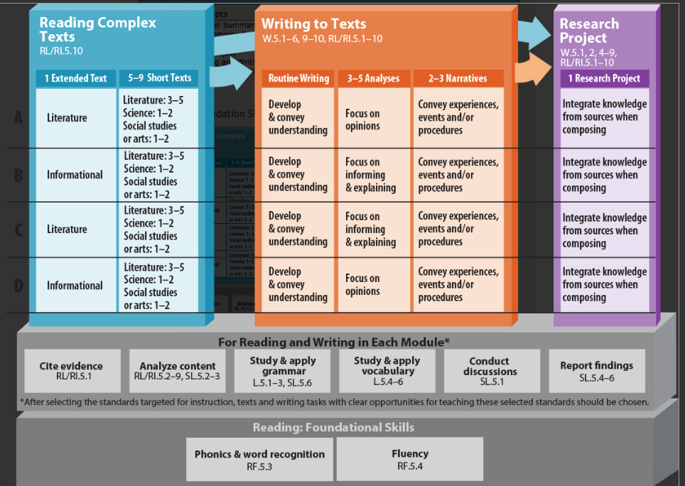
Assessments
Measuring Up Live
PARCC Assessments (sample, mid-year, end-of-year)
Teacher Assessments (see below)

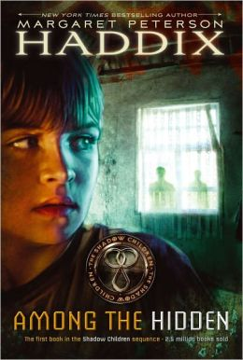
5.2 Out of the Shadows
This 14-week unit focuses on world cultures and human rights issues, connecting history to present day. Students will research and analyze fiction and nonfiction texts about human rights around the globe, focusing specifically on the population control in China and other countries.

Essential Question
- In what ways should government be allowed to regulate? How have governments benefitted and hindered the people they have served?

Building Background Knowledge
- Human Rights for Grades 3-5: http://discoverhumanrights.org/k-5
- China Population Control Relaxed (news video) www.bbc.co.uk/news/world-asia-china-24957303
- Getting Around China’s One-Child Policy (news video) http://www.wsj.com/video/getting-around-china-one-child-policy/92E49FE6-0E18-49C6-9098-996F8847E4C5.html
- Among The Hidden Movie Trailer: http://www.youtube.com/watch?v=PJFAUHkD7PU

Supplemental Materials
Fictional Texts:
Changes in the Wind/No More By Jeanie Fitchen
I Wish I Wasn't Alone by Jo
Chu Ju’s House Gloria Whealen
The Quiet World By Jeffrey McDaniel

Informational Texts:
http://kids.nationalgeographic.com/explore/countries/china.html (China facts)
http://www.timeforkids.com/destination/china China facts)
http://www.thedailybeast.com/articles/2014/01/07/as-china-s-one-child-policy-relaxes-girl-children-no-longer-stigmatized.html (One Child Policy China)
http://www.newrepublic.com/article/115614/china-one-child-policy-facts-four-surprising-findings (One child policy)

Starting on page 19 are articles that can be used on the following topics:
- Matriarchal Roles
- Patriarchal Roles
- China v United States
- China
- Overpopulation
- Rationing: Hurricane Katrina/Cuba

Novel
Among The Hidden by Margaret Haddix

Luke has never been to school. He's never had a birthday party, or gone to a friend's house for an overnight. In fact, Luke has never had a friend. Luke is one of the shadow children, a third child forbidden by the Population Police. He's lived his entire life in hiding, and now, with a new housing development replacing the woods next to his family's farm, he is no longer even allowed to go outside. Then, one day Luke sees a girl's face in the window of a house where he knows two other children already live. Finally, he's met a shadow child like himself. Jen is willing to risk everything to come out of the shadows--does Luke dare to become involved in her dangerous plan? Can he afford not to?

Key Vocabulary from Among The Hidden
By Margaret Patterson Haddix
Chapter One:

Vocabulary:
- Shudder
- Harrumphed
- Reassure
- Peered
- Umpteenth
- Runt
- Recognizable
- Protested

Chapter Two:
Vocabulary:
- Loaned
- Startled
- Crouched
- Skillet
- Insisted
- Superstition
- Hulking
- Shivered

Chapter Three:
Vocabulary:
- Careened
- Skittish
- Offended
- Deserted
- Automatically
- Slanted

Chapter Four:
Vocabulary:
- Beseechingly
- Suspicious
- Curiosity
- Hovered
- Caravan
- Scurried

Chapter Five:
Vocabulary:
- Bore
- Reciprocity

Chapter Six:
Vocabulary:
- Auction
- Comment
- Retrieve

Vocabulary:
- Linger
- Rescue
- Raged
- Fatigue

Chapter Eight:
Vocabulary:
- Complaining
- Vast
- Linoleum
- Tentatively
- Cautious
- Perch
- Apparatus
- Teetering
- Blubbered
- zeal

Chapter Nine:
Vocabulary:
- recovered
- reluctantly
- muttered
- irritable

Chapter Ten:
Vocabulary:
- yeast
- pathetic
- resignedly
- disgustedly
- incredulously
- ceremony
- guffawed
- pantomimed

Utilizing DRA Levels To Increase Student’s Reading Comprehension

Teachers should refer to these guidelines when conferring with students in guided reading and writing in order to build students’ abilities to read increasingly complex texts.

What a level40 reader needs to get to level 50+
- Be a fluent reader
- Learns new words from text
- Able to to put themes into own words
- Deep connections with other texts to help understanding
- Compare/contrast themes, topics, character traits, etc within and between texts
- Demonstrates complete understanding of text through writing
- Makes deep inferences

What a level 50+ reader needs to get a level 60
- Recognizes cultural influences of a text
- Reads like a writer
- Recognizes the purposes and structures of different genres
- Able to interpret symbolism and themes
- Thinks about multiple themes in texts
- Reads a large amount of informational text with comprehension
- Knows when comprehension is lost and use fix up strategies

What a level 60 reader needs
- Recognizes parallel plot structures
- Recognizes complex and literal language
- Can interpret more abstract themes and symbolism
- Analyzes complex characters
- Uses all the features of informational text to comprehend
- Summarizes informational text with main idea and supporting details
- Analyzes author’s validity and position

Questions/comments for conferring
Error Correction Utilizing DRA Levels Reading Behaviors
Penn Elementary, San Diego, CA

DRA Level 40
- Is the theme or big idea similar o other books you have read? Give examples.
- How have the characters influenced each other?
- How does the author reveal the character (s)?
- How does the reading this genre different from other genres?
- What connections did you make? How did that help you as a reader?
- Summarize what you read.
- What was the author’s purpose in writing this text? Theme? Main ideas?

DRA Level 50+
- How would the story change if it were written in a different place or time?
- What do you know about this culture? How did that help you understand the story?
- What does this mean? What symbolism is used?
- What is the theme of the book? Is there more than one theme? What evidence in the story supports your theme?
- What is the main idea of this informational article? What are the supporting details?
- Summarize what you read

DRA Level 60
- Is there more than one plot? Explain
- How have the characters influenced on another?
- What themes have you thought about so far?
Do you agree with the character’s actions?
- What is the author’s opinion? What evidence do you have?
- Is the author a valid source for this information? How do you know?
- Summarize what you have read so far. How does this compare with what you have read before on the topic?

Common Core Standards Taught In This Unit
Trimester 2 | Standard | Objective | Assessment
RL 5.1 | Quote text accurately to explain explicit and inferential ideas. | Identify relevant quotes to support an explicit/inferential idea from the text.  Explain explicit/inferential ideas by citing appropriate details/examples from the text. | - Story: An Excerpt from The Seven Ravens by Jacob and Wilhelm Grimm
RI 5.2 | Determine two or more main ideas from the text; identify details that support the main idea; summarize | Identify detail(s) that support the main idea.  Summarize the text.  Explain how key details support the main idea.  Identify multiple main ideas of the text. | Juiced
RI 5.3 | Explain relationships between two or more text components, using text details | Identify cause/effect relationships.  Explain how/why events/ideas developed, using text details.  Explain relationships (cause/effect, sequence, compare/contrast, chronology) between people, events, ideas, concepts, or steps in a text, using the text to support answers. | Children of the Storm (Cause and Effect)  Osceola's Last Stand Are Native American Team Names Racist? (Compare and Contrast)
RL5.4 | Determine the meaning of figurative and non-figurative words and phrases | Identify the meaning of figurative language such as metaphors/similes in a text, using context.  Identify the meaning of words/phrases as they are used in a text. | - Poem: Kites by William Rose Benet
RI 5.6 | Describe how narrator/speaker's point of view influences description of events | Identify narrator's/speaker's point of view.  Explain how narrator's/speaker's point of view influences how events are described. | Scientific Text: Three Important Organs and their Functions
RI5.5 | Compare & contrast structural differences between two texts | Identify the overall structure of events/ideas/concepts/information in two or more texts.  Describe the overall structure of events/ideas/concepts/information in two or more texts.  Compare/contrast the overall structure of events/ideas/concepts/information in two or more texts. | - Scientific Text: Bubblology adapted from www.acs.org
RI5.7 | Use information from multiple print/digital sources to solve problems.  . | Identify subheadings/headers/task bars/search functions to locate information.  Explain how subheadings/headers/task bars/search bars help solve text-based questions. | Scientific Text: The Lemming and the American Pika
RI 5.8 | Identify/Explain how author uses reasons/evidence to support points | Identify evidence that supports the author's point.  Explain how/why an author's reasons/evidence support a particular point. | Scientific Text: The Lemming and the American Pika
RL5.9 | Compare/contrast stories in the same genre on their approaches to similar themes/topics | Identify the similarities/differences between how stories in the same genre approach similar themes/topics.  Analyze how/why two or more stories in the same genre approach themes/topics in similar/different ways. | The Summer of Swans (Fictional)
W5.2 | Write an informative text on a specific topic | Develop topic with facts/definitions/details/quotations/other information/examples related to the topic in an informative/explanatory text.  Group related information logically in an informative/explanatory text.  Include formatting/illustrations/multimedia when useful to aiding comprehension in an informative/explanatory text.  Introduce a topic clearly in an informative/explanatory text.  Link ideas within categories of information using words/phrases/clauses in an informative/explanatory text.  Provide a concluding statement/section related to the information/explanation presented. | Write a composition in which you explore your choices of clothing, hairstyle, or jewelry and how those choices represent your attitude and taste. Compare and contrast your choices with those of your friends and family. Also, you may compare and contrast your present style with your style when you were younger. Conclude your composition with a paragraph in which you reflect on your style and style in general. How important do you think style is?
W5.1 | Write opinion pieces on topics/texts, supporting a point of view with reasons/information | Create an organizational structure in which ideas are logically grouped to support the writer's purpose in an opinion piece.  Introduce a topic or text clearly in an opinion piece.  Link opinions/reasons using words/phrases/clauses in an opinion piece.  Provide a concluding statement or section related to the opinion presented in an opinion piece.  Provide logically ordered reasons that are supported by facts/details.  State an opinion in an opinion piece. | A “hot topic” in the news now is the banning of firearms. One can understand with all the violence that occurs in the United States. However, critics believe that the right to bare arms helps keep families safe. What is your opinion? Do you believe that guns should be banned? Read the articles that follow explaining the pros and cons. Use the articles to help you choose a side and write an argumentative essay.
L.5.3 | Use knowledge of language and its conventions when writing, speaking, reading, or listening. | CCSS.ELA-Literacy.L.5.3a Expand, combine, and reduce sentences for meaning, reader/listener interest, and style.  CCSS.ELA-Literacy.L.5.3b Compare and contrast the varieties of English (e.g., dialects, registers) used in stories, dramas, or poems. | Question Bank: L.5.3
L.5.4 | Determine or clarify the meaning of unknown and multiple-meaning words and phrases based on grade 5 reading and content, choosing flexibly from a range of strategies. | CCSS.ELA-Literacy.L.5.4a Use context (e.g., cause/effect relationships and comparisons in text) as a clue to the meaning of a word or phrase.  CCSS.ELA-Literacy.L.5.4b Use common, grade-appropriate Greek and Latin affixes and roots as clues to the meaning of a word (e.g., photograph, photosynthesis).  CCSS.ELA-Literacy.L.5.4c Consult reference materials (e.g., dictionaries, glossaries, thesauruses), both print and digital, to find the pronunciation and determine or clarify the precise meaning of key words and phrases. | Question Bank: L.5.4

PARCC Framework for ELA

5.3 Choices That Define Us
This 14-week unit focuses on the Apartheid system of racial segregation in South Africa enforced through legislation by the National Party governments, the ruling party from 1948 to 1994. Students will explore its effects in present day through research and analysis of fiction and nonfiction texts.

Essential Question
- How do our experiences determine our choices in life? Do choices define us, or do we define our choices?

Building Background Knowledge
Videos:
- Apartheid: Facts & Summary: http://www.history.com/topics/apartheid#
- Nelson Mandela: Facts & Summary http://www.history.com/topics/nelson-mandela
- Living Under Apartheid: http://www.pbs.org/pov/twelvedisciples/video_classroom1.php#.U9rw9qWWTwI
- Non-violent Protest Against Apartheid: http://www.pbs.org/pov/twelvedisciples/video_classroom2.php#.U9rxJqWWTwI

Supplemental Materials:
Fictional:
Short Stories About Apartheid Illan Ossendryver (http://www.toursoweto.com/short-stories-of-apartheid/short-stories-of-apartheid.pdf)
Short Story: The Moment Before the Gun Went Off (http://ndla.no/en/node/3555)

Non-fictional:
Memoirs of a Native Son: http://www.people.com/people/archive/article/0,,20094029,00.html
Articles about apartheid (Chicago Tribune): http://articles.chicagotribune.com/keyword/apartheid
The History of Apartheid in South Africa: http://www-cs-students.stanford.edu/~cale/cs201/apartheid.hist.html
White House: Obama to rename program for young African leaders in honor of Nelson Mandela: http://www.usnews.com/news/politics/articles/2014/07/27/obama-to-rename-africa-program-for-nelson-mandela
Nelson Mandela’s Legacy: (Pull excerpts from this article) http://www.aucegypt.edu/gapp/cairoreview/pages/articledetails.aspx?aid=69
Nelson Mandela (Time Kids) http://www.timeforkids.com/node/97361/print

Novel
Kaffir Boy by Mark Mathabane

Mark Mathabane was weaned on devastating poverty and schooled in the cruel streets of South Africa's most desperate ghetto, where bloody gang wars and midnight police raids were his rites of passage. Like every other child born in the hopelessness of apartheid, he learned to measure his life in days, not years. Yet Mark Mathabane, armed only with the courage of his family and a hard-won education, raised himself up from the squalor and humiliation to win a scholarship to an American university.

Vocabulary from Novel

- foisted
- deportation
- impoverished
- compulsory
- virulent
- subservient
- dissuade
- verdant
- Untempered
- tallow
- resounding
- disembodied
- transfixed
- truncheons
- tenuous
- ominous
- Writhed
- unscathed
- tattered
- brandishing
- impassively
- farthings
- fabricate
- incessantly
- notorious
- itinerant

Utilizing DRA Levels To Increase Student’s Reading Comprehension

Teachers should refer to these guidelines when conferring with students in guided reading and writing in order to build students’ abilities to read increasingly complex texts.

What a level40 reader needs to get to level 50+
- Be a fluent reader
- Learns new words from text
- Able to to put themes into own words
- Deep connections with other texts to help understanding
- Compare/contrast themes, topics, character traits, etc within and between texts
- Demonstrates complete understanding of text through writing
- Makes deep inferences

What a level 50+ reader needs to get a level 60
- Recognizes cultural influences of a text
- Reads like a writer
- Recognizes the purposes and structures of different genres
- Able to interpret symbolism and themes
- Thinks about multiple themes in texts
- Reads a large amount of informational text with comprehension
- Knows when comprehension is lost and use fix up strategies

What a level 60 reader needs
- Recognizes parallel plot structures
- Recognizes complex and literal language
- Can interpret more abstract themes and symbolism
- Analyzes complex characters
- Uses all the features of informational text to comprehend
- Summarizes informational text with main idea and supporting details
- Analyzes author’s validity and position

Questions/comments for conferring
Error Correction Utilizing DRA Levels Reading Behaviors
Penn Elementary, San Diego, CA

DRA Level 40
- Is the theme or big idea similar o other books you have read? Give examples.
- How have the characters influenced each other?
- How does the author reveal the character (s)?
- How does the reading this genre different from other genres?
- What connections did you make? How did that help you as a reader?
- Summarize what you read.
- What was the author’s purpose in writing this text? Theme? Main ideas?

DRA Level 50+
- How would the story change if it were written in a different place or time?
- What do you know about this culture? How did that help you understand the story?
- What does this mean? What symbolism is used?
- What is the theme of the book? Is there more than one theme? What evidence in the story supports your theme?
- What is the main idea of this informational article? What are the supporting details?
- Summarize what you read

DRA Level 60
- Is there more than one plot? Explain
- How have the characters influenced on another?
- What themes have you thought about so far?
Do you agree with the character’s actions?
- What is the author’s opinion? What evidence do you have?
- Is the author a valid source for this information? How do you know?
- Summarize what you have read so far. How does this compare with what you have read before on the topic?

Common Core Standards Taught In This Unit

Tri 3 | Standard | Objective | Assessment
RI 5.1 | Quote text accurately to explain explicit and inferential ideas. | Identify relevant quotes to support an explicit/inferential idea from the text.  Explain explicit/inferential ideas by citing appropriate details/examples from the text. | Homemade
RL 5.1 | Quote text accurately to explain explicit and inferential ideas. | Identify relevant quotes to support an explicit/inferential idea from the text.  Explain explicit/inferential ideas by citing appropriate details/examples from the text. | Keep Looking
RI 5.2 | Determine two or more main ideas from the text; identify details that support the main idea; summarize | Identify detail(s) that support the main idea.  Summarize the text.  Explain how key details support the main idea.  Identify multiple main ideas of the text. | Taking His Best Shots and The Secrets of the Humpback Whales
RL 5.3 | Compare/contrast elements of story using text details | Compare and contrast characters, setting, or plot using specific details from the text (how plot relies on setting, how events affect character/development, etc.). | The Red Fox and Kira Kira
RI 5.4 | Determine academic vocabulary & domain-specific word meanings | Determine the meaning of unfamiliar academic and domain- specific words/phrases using context. | Long Live the Vikings
RL 5.4 | Determine the meaning of figurative and non-figurative words and phrases | Identify the meaning of figurative language such as metaphors/similes in a text, using context.  Identify the meaning of words/phrases as they are used in a text. | Short Passages: RL 5.4
RI 5.5 | Compare & contrast structural differences between two texts | Identify the overall structure of events/ideas/concepts/information in two or more texts.  Describe the overall structure of events/ideas/concepts/information in two or more texts.  Compare/contrast the overall structure of events/ideas/concepts/information in two or more text | - Scientific Text: The Boston Cooking-School Cook Book Fannie Farmer
RI5.7 | Use information from multiple print/digital sources to solve problems. | Identify subheadings/headers/task bars/search functions to locate information.  Explain how subheadings/headers/task bars/search bars help solve text-based questions. | - Recipes: Cooking with Deja and Dad
RI 5.9 | Combine information from several texts on the same topic to write/speak about the subject. | Identify the important points that are presented as similar/different in two or more texts.  Analyze how/why the key details/important points presented in two texts are similar/different.  Synthesize information from two or more texts.  Evaluate the effectiveness/quality of the information presented in two or more texts. | Jean Sexton and Marguerite Thompson
W5.1 | Write opinion pieces on topics/texts, supporting a point of view with reasons/information | Create an organizational structure in which ideas are logically grouped to support the writer's purpose in an opinion piece.  Introduce a topic or text clearly in an opinion piece.  Link opinions/reasons using words/phrases/clauses in an opinion piece.  Provide a concluding statement or section related to the opinion presented in an opinion piece.  Provide logically ordered reasons that are supported by facts/details.  State an opinion in an opinion piece. | Which kind of pet is best, a cat or a dog?  You will explain your thinking with facts and reasons from the articles. Your teacher will also give you a page of “Pet Statistics” which you can use to support your opinion if you would like.
W5.2  (SPIRAL) | Write an informative text on a specific topic | Develop topic with facts/definitions/details/quotations/other information/examples related to the topic in an informative/explanatory text.  Group related information logically in an informative/explanatory text.  Include formatting/illustrations/multimedia when useful to aiding comprehension in an informative/explanatory text.  Introduce a topic clearly in an informative/explanatory text.  Link ideas within categories of information using words/phrases/clauses in an informative/explanatory text.  Provide a concluding statement/section related to the information/explanation presented. | Think of someone who is brave. Write to describe this person and explain how he or she shows bravery.
W5.3  (SPIRAL) | Write narratives to develop real/imagined experiences/events using effective technique/descriptive details/clear event sequences | Organize an event sequence that unfolds naturally.  Orient the reader by establishing a situation/introducing a narrator/characters.  Provide a conclusion that follows from narrated experiences/events.  Use a variety of transitional words/phrases/clauses to manage sequence of events.  Use concrete words/phrases/sensory detail to convey experiences/events precisely.  Use narrative techniques to show the responses of characters to situations.  Use narrative techniques to develop experiences/events. | Think about the times that you have been influenced by peer pressure. Write a personal narrative about a time when you were pressured to do something. What was the outcome?
L.5.5 | Demonstrate understanding of figurative language, word relationships, and nuances in word meanings | CCSS.ELA-Literacy.L.5.5a Interpret figurative language, including similes and metaphors, in context.  CCSS.ELA-Literacy.L.5.5b Recognize and explain the meaning of common idioms, adages, and proverbs.  CCSS.ELA-Literacy.L.5.5c Use the relationship between particular words (e.g., synonyms, antonyms, homographs) to better understand each of the words. | Question bank: L.5.5
L.5.6 | Acquire and use accurately grade-appropriate general academic and domain-specific words and phrases, including those that signal contrast, addition, and other logical relationships (e.g., however, although, nevertheless, similarly, moreover, in addition). | N/A | Question Bank: L.5.6

PARCC FRAMEWORK FOR ELA
Assessments
Measuring Up Live
PARCC Assessments (sample, mid-year, end-of-year)
Teacher Assessments (see below)

