Lady Liberty Academy

Third Grade Curriculum

Mathematics

Revised 2014

Introduction

Lady Liberty Academy designs it math curriculum around engaging and relevant math tasks. Teachers use the program Math in Focus as a general guide with supplemental resources to expand the math instruction as needed. Math manipulatives and technology offer students an added hands-on experience with math concepts. Ultimately, the goal is for students to mentally solve number problems (math fluency) without relying on finger-counting.

Lady Liberty Academy recognizes that all students learn at different rates; therefore, teachers need to meet students at their current academic level, whether it's below grade level or above. The Vertical Progression Guide document outlines each standard as it develops in complexity through the grade levels. Teachers are expected to use the Vertical Progression Guide to fill in gaps in learning from previous grades, and to challenge advanced students who are ready for above-grade-level assignments. A vertical progression guideline is located at the end of each grade level curriculum.

All of our curriculum units may be found online through the Departments tab on our school website at www.LLACS.org.

Grade 3 Mathematics Unit 1

Properties of Multiplication and Division, Solving Problems w/Units of 2,5 and 10

Focus Grade Level Standards
Represent and solve problems involving multiplication and division.
- 3.OA.1 Interpret products of whole numbers, e.g., interpret 5 × 7 as the total number of objects in 5 groups of 7 objects each. For example, describe a context in which a total number of objects can be expressed as 5 × 7.
- 3.OA.2 Interpret whole-number quotients of whole numbers, e.g., interpret 56 ÷ 8 as the number of objects in each share when 56 objects are partitioned equally into 8 shares, or as a number of shares when 56 objects are partitioned into equal shares of 8 objects each. For example, describe a context in which a number of shares or a number of groups can be expressed as 56 ÷ 8.
- 3.OA.3 Use multiplication and division within 100 to solve word problems in situations involving equal groups, arrays, and measurement quantities, e.g., by using drawings and equations with a symbol for the unknown number to represent the problem. (See Glossary, Table 2.)
- 3.OA.4 Determine the unknown whole number in a multiplication or division equation relating three whole numbers. For example, determine the unknown number that makes the equation true in each of the equations 8 × ? = 48, 5 = _ ÷ 3, 6 × 6 = ?

Understand properties of multiplication and the relationship between multiplication and division.
- 3.OA.5 Apply properties of operations as strategies to multiply and divide. (Students need not use formal terms for these properties.) Examples: If 6 × 4 = 24 is known, then 4 × 6 = 24 is also known. (Commutative property of multiplication.) 3 × 5 × 2 can be found by 3 × 5 = 15, then 15 × 2 = 30, or by 5 × 2 = 10, then 3 × 10 = 30. (Associative property of multiplication.) Knowing that 8 × 5 = 40 and 8 × 2 = 16, one can find 8 × 7 as 8 × (5 + 2) = (8 × 5) + (8 × 2) = 40 + 16 = 56. (Distributive property.)
- 3.OA.6 Understand division as an unknown-factor problem. For example, find 32 ÷ 8 by finding the number that makes 32 when multiplied by 8.

Multiply and divide within 100.
- 3.OA.7 Fluently multiply and divide within 100, using strategies such as the relationship between multiplication and division (e.g., knowing that 8 × 5 = 40, one knows 40 ÷ 5 = 8) or properties of operations. By the end of Grade 3, know from memory all products of two one-digit numbers.

Solve problems involving the four operations, and identify and explain patterns in arithmetic.
- 3.OA.8 Solve two-step word problems using the four operations. Represent these problems using equations with a letter standing for the unknown quantity. Assess the reasonableness of answers using mental computation and estimation strategies including rounding. (This standard is limited to problems posed with whole numbers and having whole-number answers; students should know how to perform operations in the conventional order when there are no parentheses to specify a particular order, i.e., Order of Operations.)

Standards | Topics and Objective | Math In Focus | Days
Benchmark/Pre-Test to be administers Approximate September 12
3.OA.1  3.OA.3 | Multiplication and the Meaning of Factors  - Understand equal groups of as multiplication.  - Relate multiplication to the array model.  - Interpret the meaning of factors - the size of the group or the number of groups | Ch. 6 | 3
3.OA.2  3.OA.6  3.OA.3  3.OA.4 | Division as an Unknown Factor Problem  - Understanding the meaning of the unknown factor as the size of the group in division  - Understanding the meaning of the unknown as the number of groups in division.  - Interpret the unknown factor in division using the array model | Ch. 6  Ch. 8  Ch. 9  Ch. 12 | 3
3.OA.1  3.OA.5  3.OA.3  3.OA.4 | Analyze Arrays Using Units of 2 and 3  - Demonstrate the commutativity of multiplication and practice related facts by skip-counting object in arrays models  - Find related multiplication facts by adding and subtracting equal groups in array models. | Ch. 6  Ch. 7  Ch. 8  Ch. 9  Ch. 12 | 4
Biweekly Assessment administered: Approximately September 26
3.OA.2  3.OA.4  3.OA.6  3.OA.7  3.OA.3.  3.OA.8 | Division Using Units of 2 and 3  - Model division as the unknown factor in multiplication using arrays and tape diagrams.  - Interpret the quotient as the number of groups or the number of objects in each group using units of 2.  - Interpret the quotient as the number of groups or the number od objects in each group using units of 3 | Ch. 6  Ch. 7  Ch. 8  Ch. 9  Ch. 12 | 3
3.OA.5  3.OA.7  3.OA.1  3.OA.2  3.OA.3  3.OA.4  3.OA.6 | Multiplication and Division Using Units of 4  - Skip-count objects in models to build fluency with multiplication facts using units of 4  - Relate arrays to tape diagrams to model the commutative property of multiplication  - Use the distributive property as a strategy to find related multiplication facts.  - Model the relationship between multiplication and division. | Ch. 6  Ch. 7  Ch. 8  Ch. 9  Ch. 12 | 4
Biweekly Assessment administered: Approximately October 10
3.OA.3  3.OA.5  3.OA.7  3.OA.8  3.OA.1  3.OA.2  3.OA.4  3.OA.6 | Distributive Property and Problem Solving Using Units of 2-5 and 10  - Apply the distributive property to decompose units  - Solve two-step word problems involving multiplication and division and assess the reasonableness of answers.  - Solve two-step word problems involving all four operations and assess the reasonableness of answers | Ch. 2  Ch. 5  Ch. 6  Ch. 7  Ch. 8  Ch. 9  Ch. 12 | 4
End of Unit Assessment administered: Approximately October 24

Essential Question:
- How are multiplication and division related?
- How do we use multiplication and division to solve problems?
- What are the properties of multiplication?
- What strategies can we use to memorize facts?

Key Vocabulary:
- Array (a set of numbers or objects that follow a specific pattern, a matrix)
- Column (e.g., in an array)
- Commutative Property/Commutative (e.g., rotate a rectangular array 90 degrees to demonstrate that factors in a multiplication sentence can switch places)
- Equal groups (with reference to multiplication and division; one factor is the number of objects in a group and the other is a multiplier that indicates the number of groups)
- Equation (a statement that 2 expressions are equal. E.g., 3 × 4 = 12)
- Distribute (with reference to the Distributive Property; e.g. In 12 × 3 = (10 × 3) + (2 × 3) the 3 is multiplier for each part of the decomposition)
- Divide/division (partitioning a total into equal groups to show how many equal groups add up to a specific number. E.g., 15 ÷ 5 = 3)
- Fact (used to refer to multiplication facts, e.g., 3 × 2)
- Factors (i.e., numbers that are multiplied to obtain a product)
- Multiplication/multiply (an operation showing how many times a number is added to itself e.g., 5 × 3 =15)
- Number of groups (factor in a multiplication problem that refers to the total equal groups)
- Parentheses (e.g., ( ) used around a fact or numbers within an equation)
- Quotient (the answer when one number is divided by another)
- Rotate (turn, used with reference to turning arrays 90 degrees)
- Row/column (in reference to rectangular arrays)
- Size of groups (factor in a multiplication problem that refers to how many in a group)
- Unit (i.e., one segment of a partitioned tape diagram)
- Unknown (i.e., the “missing” factor or quantity in multiplication or division)

Check for Prior Knowledge:
Students should already be familiar with the following standards:
- 2.OA.3 Determine whether a group of objects (up to 20) has an odd or even number of members, e.g., by pairing objects or counting them by 2s; write an equation to express an even number as a sum of two equal addends.
- 2.OA.4 Use addition to find the total number of objects arranged in rectangular arrays with up to 5 rows and up to 5 columns; write an equation to express the total as a sum of equal addends.
- 2.NBT.2 Count within 1000; skip-count by 5s, 10s, and 100s.

Links:
- BrainPop Video on Multiplication: http://www.brainpop.com/math/numbersandoperations/multiplication
- BrainPop Video on Commutative Property: http://www.brainpop.com/math/numbersandoperations/commutativeproperty/
- BrainPop Video on Distributive Property: http://www.brainpop.com/math/numbersandoperations/distributiveproperty/
- BrainPop Jr. Videos on Multiplication: http://www.brainpopjr.com/search/?keyword=multiplication
- LearnZillion.com to browse lessons by standard
- Zearn.com for ongoing online multiplication practice with tracking and assessment

Relevant Suggested Student Project:
- Everyday Arrays: Students identify arrays in their environment (school, home, store, etc.), Describe them using multiplication, groups of, repeated addition. Students then find creative ways to display them.
- Math Tic-Tac-Toe: Complete 3 activities in a vertical, horizontal, or diagonal line. You may complete more than 3 activities if you wish. Activities include creating a study guide, poster, game design, multimedia presentation, real world application, poetry etc.
- Create a Math Storybook: In this project you can choose to create a math story book for our class library or a math story book to donate to a class library for another grade level.
Name Date September 26, 2014
1. Mrs. Tran plants 2 rows of 5 carrots in her garden.
- Draw an array that represents Mrs. Tran’s carrots using an X to show each carrot.

- Mrs. Tran adds 3 more rows of 5 carrots to her garden.
- Use circles to show her new carrots on the array in Part (a).
- Complete the number sentence below showing how she added five rows.

________ fives + ________ fives = ________ fives

- Write a sentence to explain your thinking.

- Find the total number of carrots Mrs. Tran planted.

- Write a multiplication sentence to describe the array representing the total number of carrots
Mrs. Tran planted.

2. Mrs. Tran picks 15 tomatoes from her garden. She puts 5 tomatoes in each bag.
- Draw Mrs. Tran’s bags of tomatoes.

- Write and solve a multiplication sentence to describe your drawing in Part (a).

- Mrs. Tran plants 12 sunflowers in her garden. She plants them in 3 rows.
- Write a division sentence in the spaces below. What does the answer represent?

_______ ÷ _______ = _______

- Mrs. Tran adds 2 more identical rows of sunflowers to her 3 original rows. Draw an array to show how many flowers she has now.

- Mrs. Tran figured out how many flowers she planted. Her work is shown in the box below.
Would Mrs. Tran get the same result if she multiplied 5 x 4? Explain why or why not.
(3 x 4) + (2 x 4) = 12 + 8
= 20

Assessment Task
Standards Addressed
Represent and solve problems involving multiplication and division.
3.OA.1 Interpret products of whole numbers, e.g., interpret 5 × 7 as the total number of objects in 5 groups of 7 objects each. For example, describe a context in which a total number of objects can be expressed as 5 × 7.
3.OA.2 Interpret whole-number quotients of whole numbers, e.g., interpret 56 ÷ 8 as the number of objects in each share when 56 objects are partitioned equally into 8 shares, or as a number of shares when 56 objects are partitioned into equal shares of 8 objects each. For example, describe a context in which a number of shares or a number of groups can be expressed as 56 ÷ 8.
Understand properties of multiplication and the relationship between multiplication and division.
3.OA.5 Apply properties of operations as strategies to multiply and divide. (Students need not use formal terms for these properties.) Examples: If 6 × 4 = 24 is known, then 4 × 6 = 24 is also known. (Commutative property of multiplication.) 3 × 5 × 2 can be found by 3 × 5 = 15, then 15 × 2 = 30, or by 5 × 2 = 10, then 3 × 10 = 30. (Associative property of multiplication.) Knowing that 8 × 5 = 40 and 8 × 2 = 16, one can find 8 × 7 as 8 × (5 + 2) = (8 × 5) + (8 × 2) = 40 + 16 = 56. (Distributive property.)
3.OA.6 Understand division as an unknown-factor problem. For example, find 32 ÷ 8 by finding the number that makes 32 when multiplied by 8.

Scoring Rubric
Assessment  Task Item and Standards Addressed | STEP 1  Little evidence of reasoning without a correct answer.  (1 Point) | STEP 2  Evidence of some reasoning without a correct answer.  (2 Points) | STEP 3  Evidence of some reasoning with a correct answer or evidence of solid reasoning with an incorrect answer.  (3 Points) | STEP 4  Evidence of solid reasoning with a correct answer.  (4 Points)
1  3.OA.1  3.OA.2  3.OA.6 | Student answers at least one question correctly. | Student answers at least two questions correctly. | Student answers at least three questions correctly. Mistakes may include the following:  - Completes the number sentence in Part b incorrectly  - Provides inaccurate explanation in Part (b)  - Writes a number sentence for Part (d) that describes the original array in Part A (2 x 5 or 5 x 2) | Student answers every question correctly:  - Draws accurate arrays  - Accurately completes the number sentence in Part (b)  - Provides accurate explanation of the number sentence in Part (b)  - Accurately find the total number of carrots  - Writes 5 x 5 in Part (d) (may or may not provide solution)
2  3.OA.1 | Student is unable to answer either question correctly. The attempt shows the student may not understand the meaning of the questions. | Student may or may not answer one question correctly. Mistakes may include those listed in the box to the right, and/or  - Draws unequal groups  Writes a number sentence using 5, 3, and 15, but a symbol or operation other than multiplication | Student answers at least one question correctly. Mistakes may include one of the following:  - Draws 5 equal groups  - Writes 15 as a factor | Student correctly:  - Represents 3 groups, each with a value of 5  - Writes 5 x 3 = 15 or 3 x 5 = 15
3  3.OA.1  3.OA.5 | Student is unable to answer any question correctly. The attempt shows the student may not understand the meaning of the questions. | Student answers at least one question correctly. Mistakes may include those listed in the box to the right, and/or  - Mixes up the order of numbers in the division sentence (e.g., 3 ÷ 12 = ?)  - Incorrectly identifies what the answer represents in Part A  - Inaccurately draws the array | Student answers at least two questions correctly. Mistakes may include:  - Not identifying the distributive property in Part (c)  - Explanation may only recognize that 5 x 4 also equals 20 | Student correctly:  - Writes 12 ÷ 3 = 4  - Identifies that the answer represents the number of flowers in each row  - Draws an array  - Writes an explanation that includes the distributive property (may or may not  use the words distributive property)

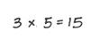
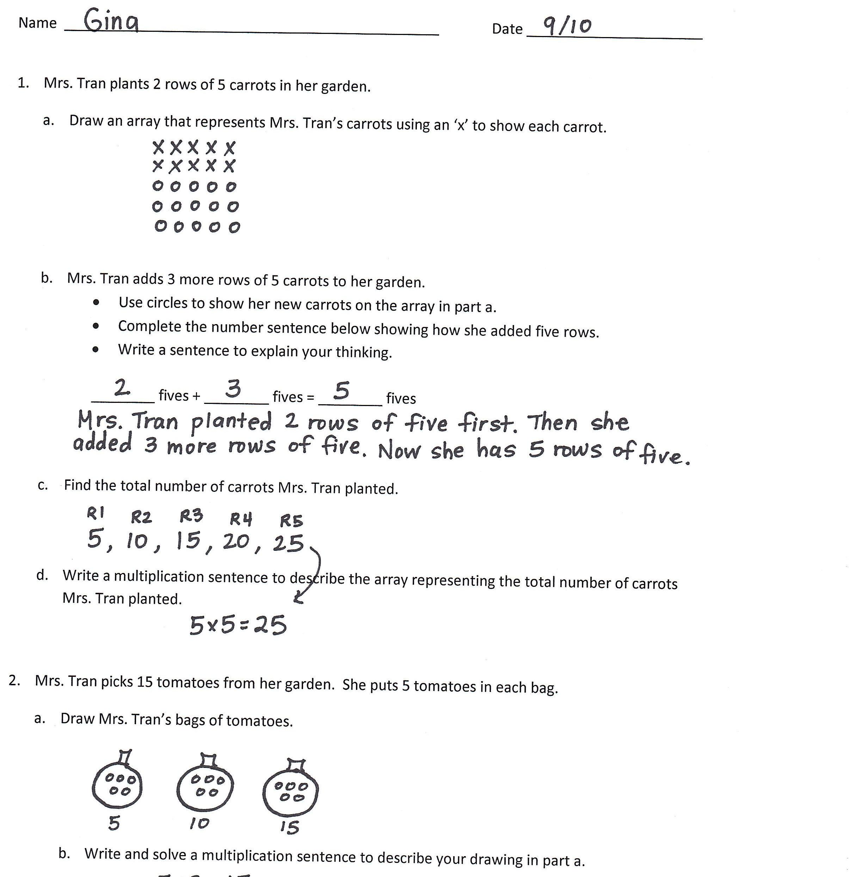

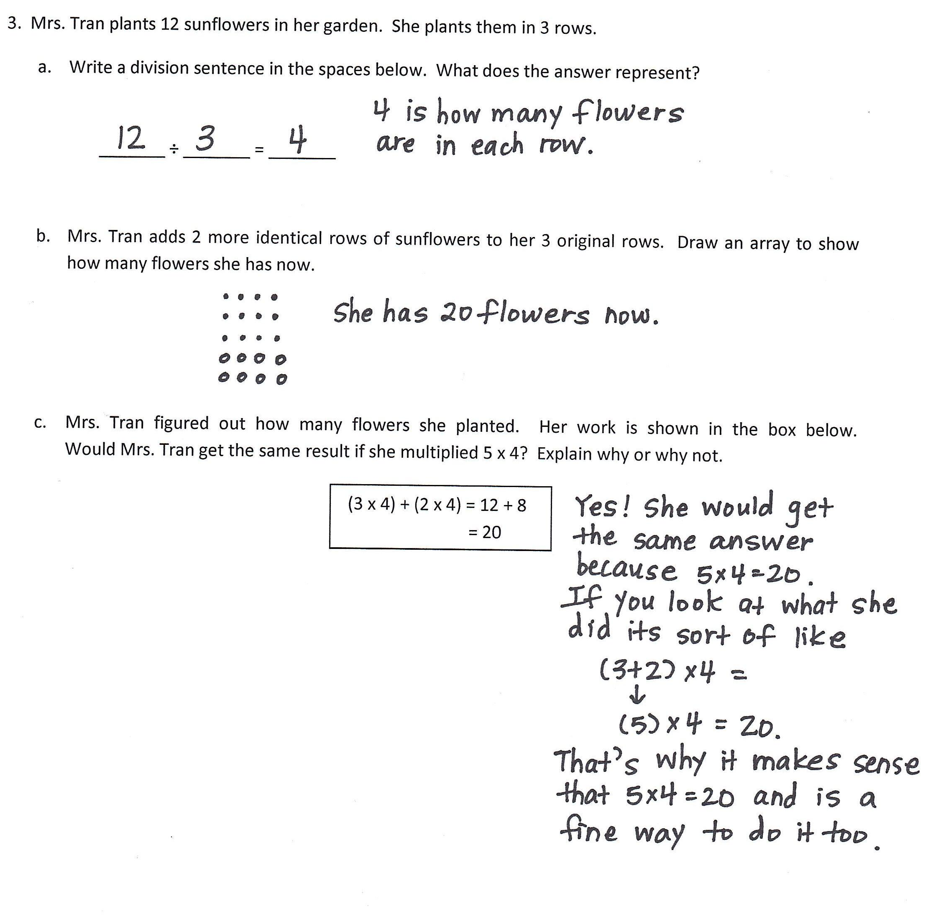

Name Date October 10, 2014
Biweekly assessment
Topics D & E
Name Date October 24, 2014

- Melanie works in a bakery. She bakes different types of breads. She bakes 18 biscuits on a pan. 3 rows fit on the pan. Draw an array to show the total number of biscuits.

- Fill in the missing factor. Write a sentence telling what it represents.

3 x _______ = 18

- Write a related division sentence to find the number of biscuits in each row.

- Melanie packs the 18 biscuits into bags of 2.

- Draw a picture to show how many bags of biscuits Melanie packs. How many bags of biscuits does she pack?

- Melanie bakes 18 rolls and packs them into bags of 9. Draw a picture to show how many bags of rolls Melanie packs. How many bags of rolls does she pack?

- Draw an array to represent her biscuits. Draw a second array to represent her rolls. Explain the relationship between the 2 arrays using number sentences and words.

- Melanie bakes cupcakes for a birthday party. They are shown to the right. 20 are vanilla and 20 are chocolate. This shows how she calculated the total number of cupcakes:
o o o o o
o o o o o
o o o o o
o o o o o

o o o o o
o o o o o
o o o o o
o o o o o

(4 x 5) + (4 x 5) = 8 x 5
- Use Melanie’s method to find the total. Explain each step with words.

o o o o o
o o o o o
o o o o o
o o o o o
o o o o o
o o o o o

o o o o o
o o o o o

- She burns 2 rows of five cupcakes. Fill in the unknowns below to describe how many are on the plate and how many are burnt.

- x 5 = _____ x 5 + _____ x 5

- Melanie decides to bake blueberry muffins next. Her recipe calls for 5 blueberries per muffin. She makes 10 muffins.

- Draw a picture and write a multiplication sentence to find the total number of blueberries she uses for 10 muffins.

- Melanie uses the equation 10 = _____ ÷ 5 to figure out how many blueberries she needs. Is her method correct? Why or why not?

- If she has a total of 90 blueberries, how many are left after she makes the 10 muffins?

- She boxes the 10 muffins. Each box fits 2. Draw a picture and write a number sentence to show how many boxes Melanie fills.

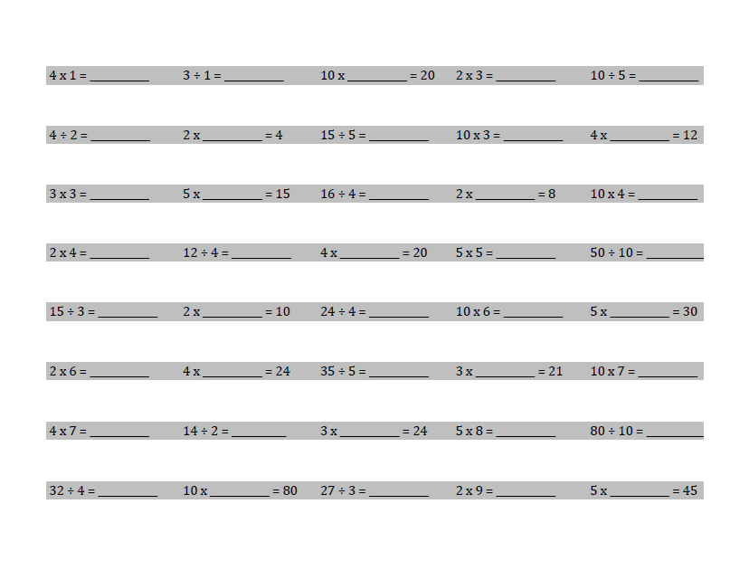
5. Complete as many problems as you can in 100 seconds. The teacher will time you and tell you when to stop.

Assessment Task
Standards Addressed
Represent and solve problems involving multiplication and division.
3.OA.1 Interpret products of whole numbers, e.g., interpret 5 × 7 as the total number of objects in 5 groups of 7 objects each. For example, describe a context in which a total number of objects can be expressed as 5 × 7.
3.OA.2 Interpret whole-number quotients of whole numbers, e.g., interpret 56 ÷ 8 as the number of objects in each share when 56 objects are partitioned equally into 8 shares, or as a number of shares when 56 objects are partitioned into equal shares of 8 objects each. For example, describe a context in which a number of shares or a number of groups can be expressed as 56 ÷ 8.
3.OA.3 Use multiplication and division within 100 to solve word problems in situations involving equal groups, arrays, and measurement quantities, e.g., by using drawings and equations with a symbol for the unknown number to represent the problem. (See Glossary, Table 2.)
3.OA.4 Determine the unknown whole number in a multiplication or division equation relating three whole numbers. For example, determine the unknown number that makes the equation true in each of the equations 8 × ? = 48, 5 = _ ÷ 3, 6 × 6 = ?
Understand properties of multiplication and the relationship between multiplication and division.
3.OA.5 Apply properties of operations as strategies to multiply and divide. (Students need not use formal terms for these properties.) Examples: If 6 × 4 = 24 is known, then 4 × 6 = 24 is also known. (Commutative property of multiplication.) 3 × 5 × 2 can be found by 3 × 5 = 15, then 15 × 2 = 30, or by 5 × 2 = 10, then 3 × 10 = 30. (Associative property of multiplication.) Knowing that 8 × 5 = 40 and 8 × 2 = 16, one can find 8 × 7 as 8 × (5 + 2) = (8 × 5) + (8 × 2) = 40 + 16 = 56. (Distributive property.)
3.OA.6 Understand division as an unknown-factor problem. For example, find 32 ÷ 8 by finding the number that makes 32 when multiplied by 8.
Multiply and divide within 100.
3.OA.7 Fluently multiply and divide within 100, using strategies such as the relationship between multiplication and division (e.g., knowing that 8 x 5 = 40, one knows 40 ÷ 5 = 8) or properties of operations. By the end of Grade 3, know from memory all products of two one-digit numbers.
Solve problems involving the four operations, and identify and explain patterns in arithmetic.
3.OA.8 Solve two-step word problems using the four operations. Represent these problems using equations with a letter standing for the unknown quantity. Assess the reasonableness of answers using the mental computation and estimation strategies including rounding. (This standard is limited to problems posed with whole numbers and having whole-number answers; students should know how to perform operations in the conventional order when there are no parentheses to specify a particular order, i.e., Order of Operations.)

Rubric
Assessment  Task Item and Standards Addressed | STEP 1  Little evidence of reasoning without a correct answer.  (1 Point) | STEP 2  Evidence of some reasoning without a correct answer.  (2 Points) | STEP 3  Evidence of some reasoning with a correct answer or evidence of solid reasoning with an incorrect answer.  (3 Points) | STEP 4  Evidence of solid reasoning with a correct answer.  (4 Points)
1  3.OA.2  3.OA.3  3.OA.4  3.OA.7 | Student is unable to answer any question correctly. The attempt shows the student may not understand the meaning of the questions. | Student answers at least one question correctly. Mistakes may include those listed in the box to the right, and/or  - Writes the incorrect factor in the multiplication sentence  - Does not show understanding of the meaning of the unknown factor  - Writes an incorrect division sentence | Student answers at least two questions correctly. Mistakes may include the following:  - Incorrectly writes in the missing factor, but understands that it represents the number of cookies in each row  - Places the numbers incorrectly in the division sentence | Student correctly:  - Draws an array  - Fills in the missing factor (6) and understands what it represents  - Writes a related division sentence (18 ÷ 3 = 6)
2  3.OA.2  3.OA.3  3.OA.5 | Student attempts to draw the picture. The attempt, however, shows the student may not understand the meaning of the questions. | Student answers at least one question correctly. Mistakes may include those listed in the box to the right, and/or:  - Draws incorrect pictures of the number of bags of chocolate chip cookies and sugar cookies  - Attempts to draw the 2 arrays, but inaccurately explains the relationship between them | Student answers at least two questions correctly. Mistakes may include the following:  - Incorrectly calculates the number of bags either in Part (a) or Part (b)  - Draws the arrays correctly but explanation includes some inaccuracies | Student answers every question correctly:  - Finds the number of bags Melanie packs for chocolate chip cookies and sugar cookies.  - Draws 2 arrays to represent the chocolate chip cookies and sugar cookies  - Provides an accurate explanation of the commutative property in Part (c)
3  3.OA.1  3.OA.3  3.OA.5 | Student is unable to answer either question correctly. The attempt shows the student may not understand the meaning of the questions.  (continued) | Student attempts to answer the questions. Mistakes may include those listed in the box to the right, and/or  - Finds the incorrect total number of cupcakes  - Unable to explain Melanie’s method  - Incorrectly fills in the equation in Part (b) | Student answers at least one question correctly. Mistakes may include the following:  - Finds the total number of cupcakes but explanation in Part (a) includes some inaccuracies  - Incorrectly fills in the unknowns in Part (b) | Student correctly:  - Explains each step of Melanie’s method in words  - Calculates the total number of cupcakes as 40.  - Correctly fills in the unknowns in Part (b)
4  3.OA.1  3.OA.2  3.OA.3  3.OA.6  3.OA.8 | Student is unable to answer either question correctly. The attempt shows the student may not understand the meaning of the questions. | Student attempts to answer the questions. Mistakes may include those listed in the box to the right, and/or  - Draws inaccurate pictures  - Writes incorrect number sentences  - Incorrectly calculates the number of blueberries in Part (a) and/or boxes in Part (d) | Student answers at least one question correctly. Mistakes may include the following:  - Incorrectly calculates the numbers of blueberries or boxes used  - Limited understanding demonstrated in explanation for Part (b)  - Incorrectly calculates how many blueberries are left  - Uses incorrect numbers to write number sentences | The student correctly:  - Draws pictures to find the answers in Parts (a) and (d)  - Clearly understands division as an unknown factor problem in Part (b)  - Calculates the correct number of blueberries remaining in Part (c)  - Calculates the total number of blueberries and boxes  - Writes the correct numbers sentences in all parts
5  3.OA.7 | Use the attached sample work to correct students’ answers on the fluency page of the assessment.  Students who answer 30 or more questions correctly within the allotted time “pass” this portion of the assessment. They are ready to move on to the more complicated fluency page given with the Module 2 End-of-Module Assessment. For students who do not pass, you may choose to re-administer this fluency page with each subsequent end-of-module assessment until they are successful.  Analyze the mistakes students make on this assessment to further guide your fluency instruction. Possible questions to ask as you analyze are:  - Did this student struggle with multiplication, division, or both?  - Did this student struggle with a particular factor?  - Did the student consistently miss problems with the unknown in a particular position?
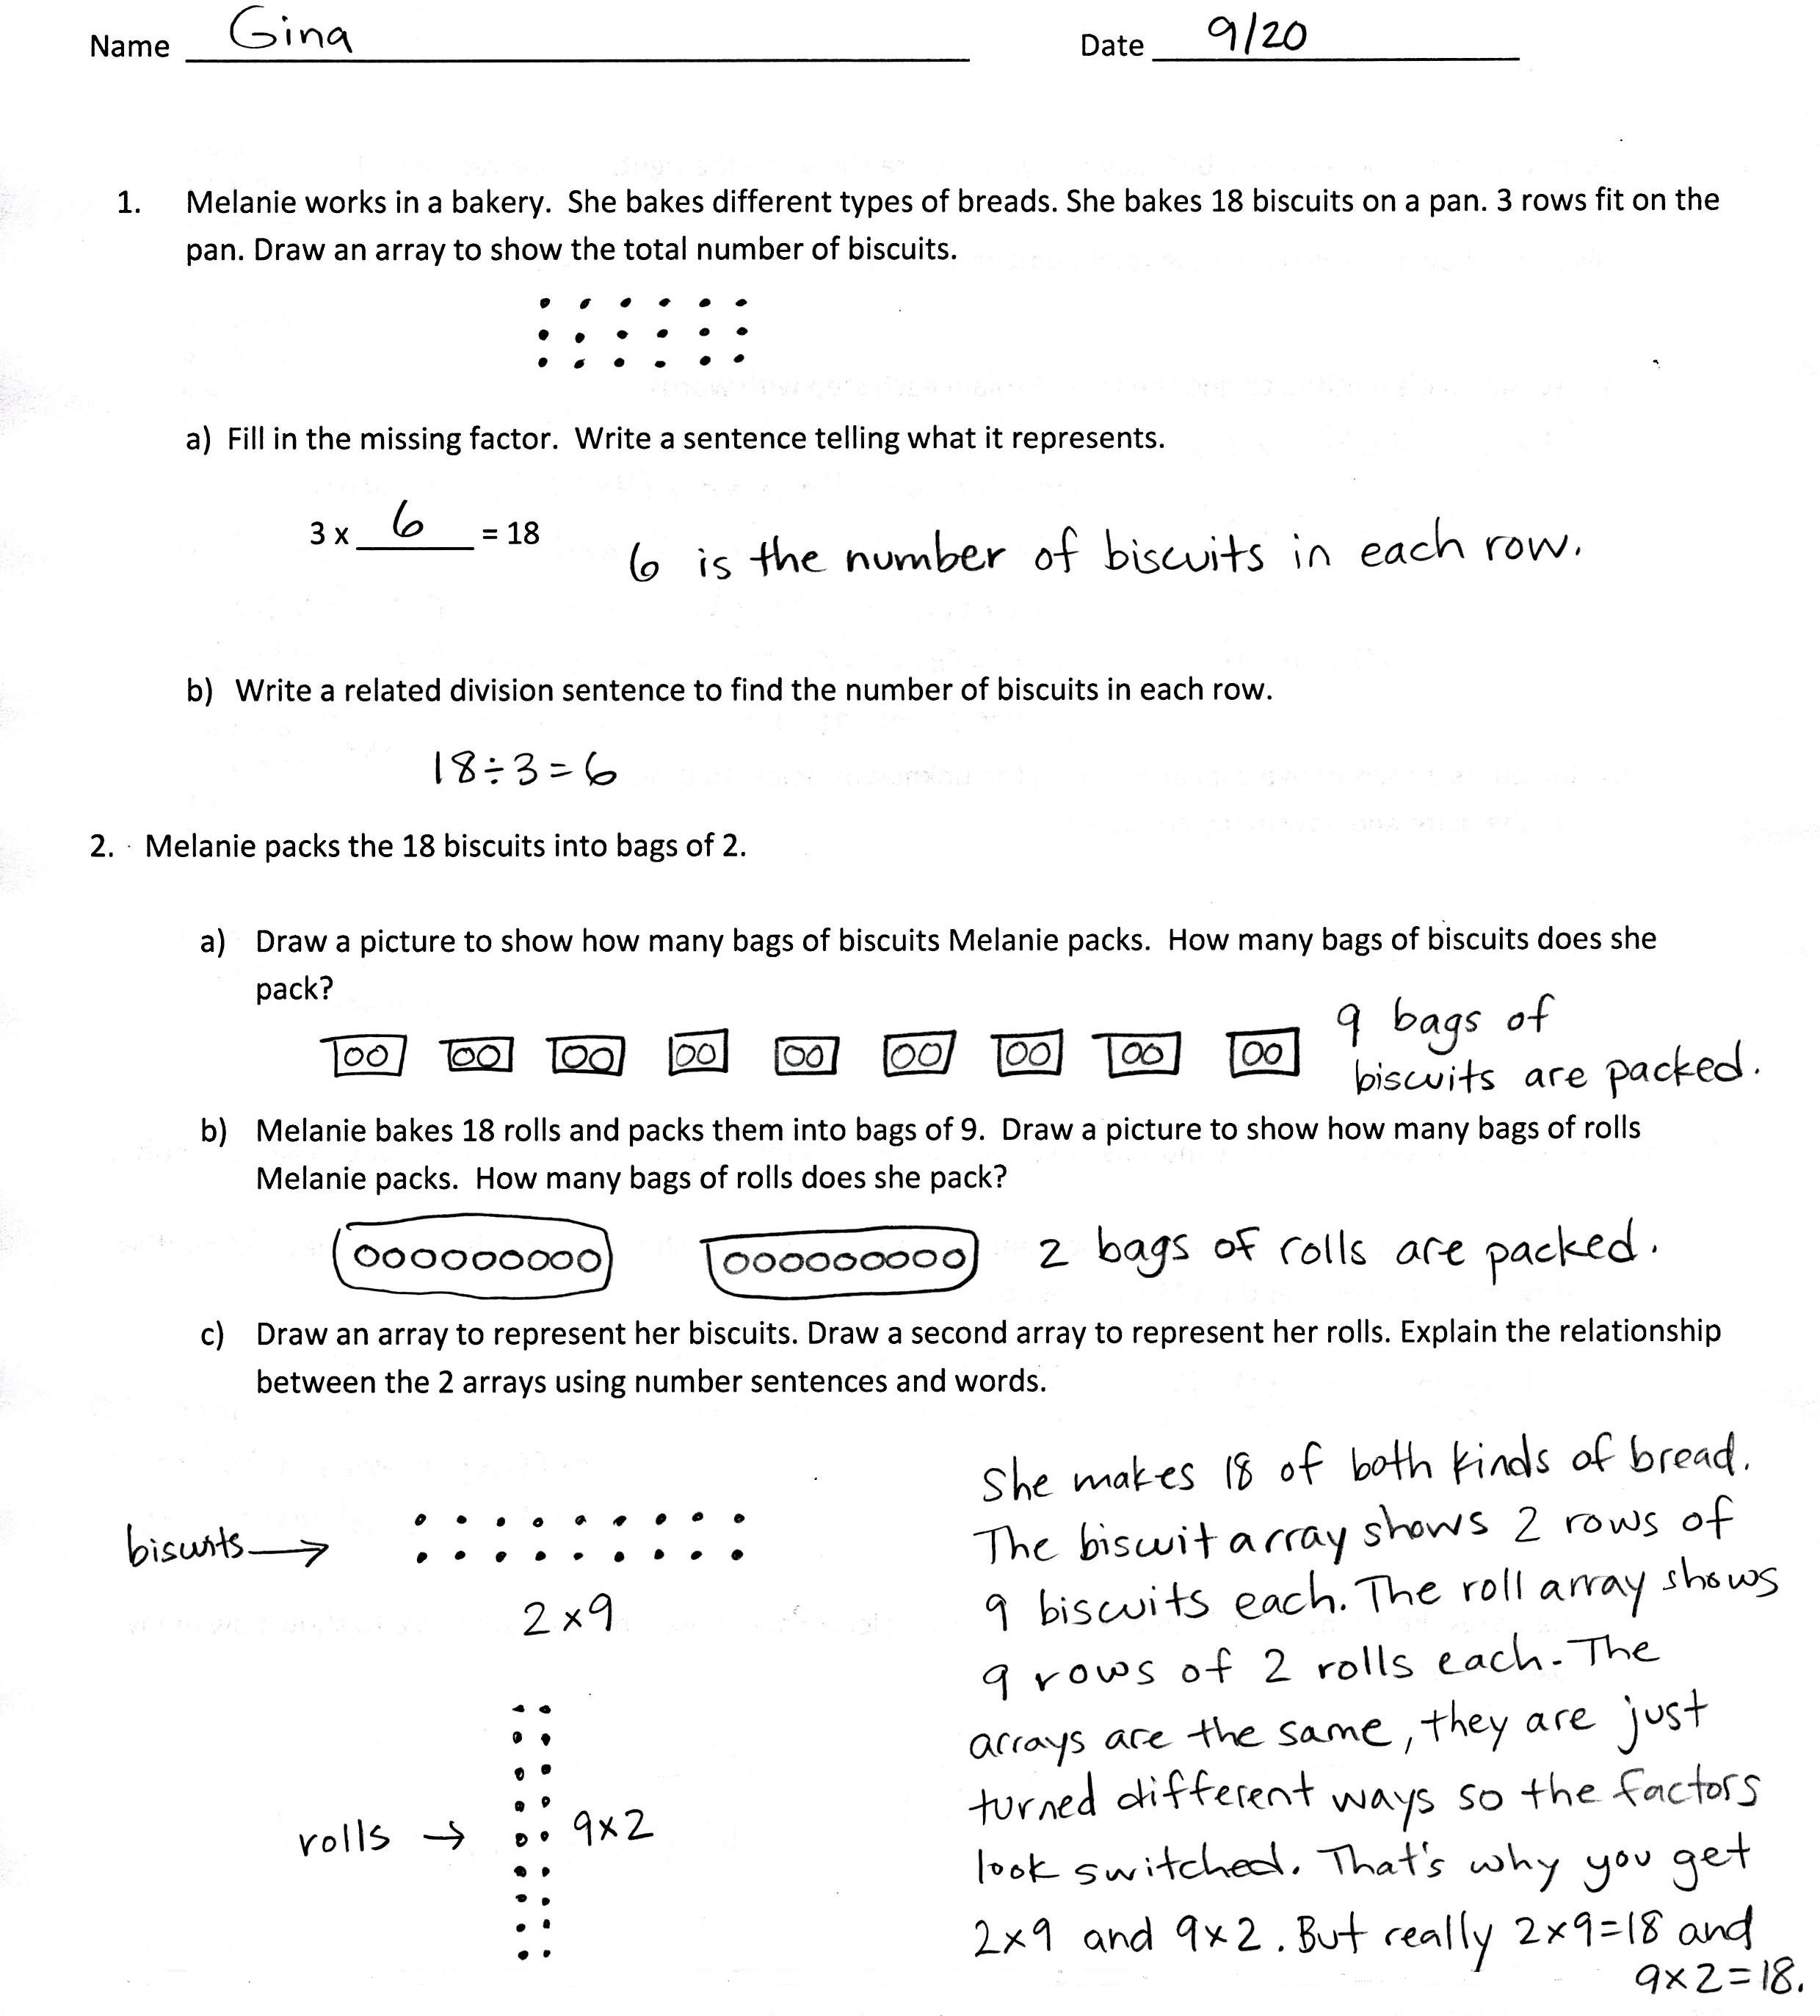
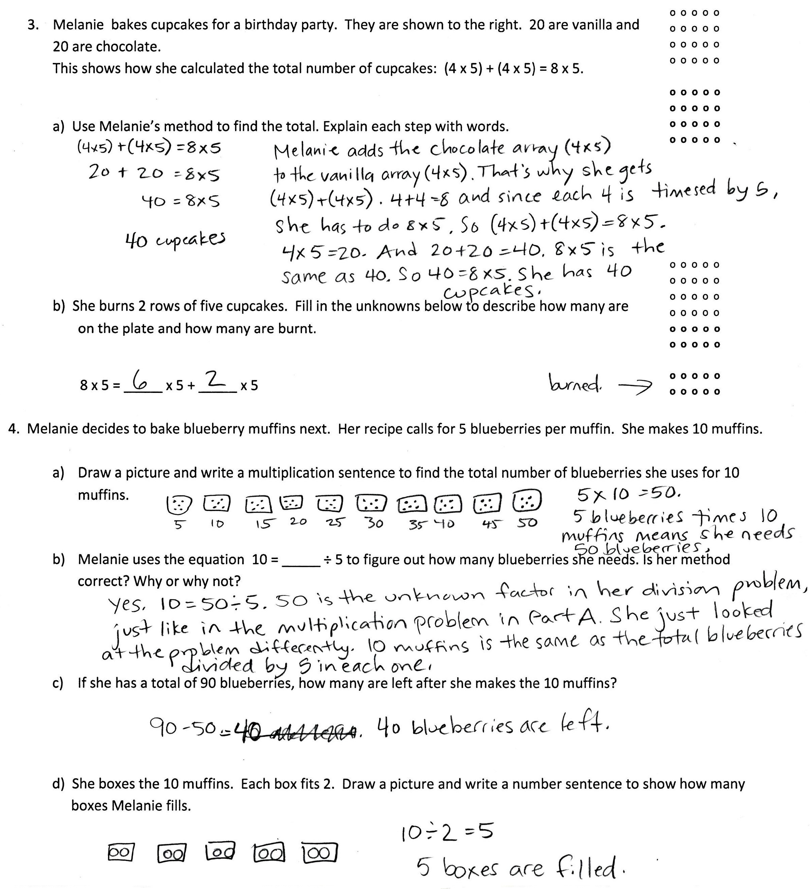
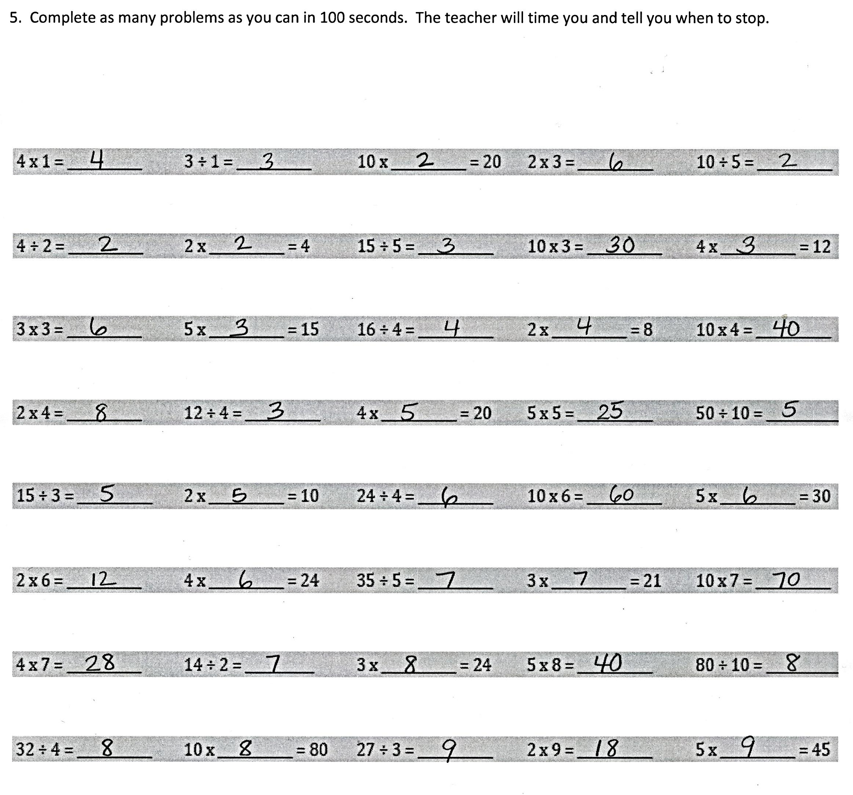

Third Grade Math Unit 2

Place Value and Problem Solving with Units of Measure

Focus Grade Level Standards
Use place value understanding and properties of operations to perform multi-digit arithmetic.
- 3.NBT.1 Use place value understanding to round whole numbers to the nearest 10 or 100.
- 3.NBT.2 Fluently add and subtract within 1000 using strategies and algorithms based on place value, properties of operations, and/or the relationship between addition and subtraction.

Solve problems involving measurement and estimation of intervals of time, liquid volumes, and masses of objects.
- 3.MD.1 Tell and write time to the nearest minute and measure time intervals in minutes. Solve word problems involving addition and subtraction of time intervals in minutes, e.g., by representing the problem on a number line diagram.
- 3.MD.2 Measure and estimate liquid volumes and masses of objects using standard units of grams (g), kilograms (kg), and liters (l). Add, subtract, multiply, or divide to solve one-step word problems involving masses or volumes that are given in the same units, e.g., by using drawings (such as a beaker with a measurement scale) to represent the problem.

Pacing Guide
Standards | Topics and Objective | Math In Focus | Days
3.NBT.2  3.MD.1 | Time Measurement and Problem Solving  - Explore time as a continues measurement using a stopwatch  - Relate skip counting by 5 on the clock and telling time to continuous measurement model, the number line.  - Count by fives and ones on the number line as a strategy to tell time to the nearest minute on the clock.  - Solve word problems involving time intervals within 1 hour by counting backward and forward using the number line and clock.  - Solve word problems involving time intervals within 1 hour by adding and subtracting on the number line. | Ch. 2  Ch. 5  Ch. 12  Ch. 16 | 5
3.NBT.2  3.MD.2  3.NBT.8 | Measuring Weight an Liquid Volume in Metric Units  - Build and decompose a kilogram to reason about the size and weight of 1 kilogram, 100 grams, 10 grams and 1 gram.  - Develop estimation strategies by reasoning about the weight in kilograms of a series of familiar objects to establish mental benchmark measure.  - Solve one-step word problems involving metric weights within 100 and estimate to reason about solutions.  - Decompose a liter to reason about the size of 1 liter, 100 milliliters, 10 milliliters, and 1 milliliter  - Estimate and measure liquid volume in liters and milliliters using the vertical number line  - Solved mixed word problems involving all four operations with grams, kilograms, liters, and milliliters given in the same unit. | Ch. 2  Ch. 5  Ch. 11  Ch. 12 | 6
3.NBT.1  3.MD.1  3.MD.2 | Rounding to the Nearest Ten and Hundred  - Round two-digit measurements to the nearest ten on the vertical number line.  - Round two - and three-digit numbers to the nearest ten on the vertical number-line  - Round to the nearest hundred on the vertical number line. | Ch. 2  Ch. 3  Ch. 4  Ch. 11  Ch. 16 | 3
Biweekly Assessment administered approximately November 7
3.NBT.2  3.NBT.1  3.MD.1  3.MD.2 | Two- and Three-Digit Measurement Addition Using the Standard Algorithm  - Add measurements using the standard algorithm to compose larger units once.  - Add measurements using the standard algorithm to compose larger units twice.  - Estimate sums by rounding and apply to solve measurement word problems. | Ch. 2  Ch. 5  Ch. 12 | 3
3.NBT.2  3.NBT.1  3.MD.1  3.MD.2 | Two- and Three-Digit Measurement Subtraction Using the Standard Algorithm  - Decompose once to subtract measurements including three-digit minuends with zeros in the tens or ones place.  - Decompose twice to subtract measurements including three-digit minuends with zeros in the tens and ones places.  - Estimate differences by rounding and apply to solve measurement word problems.  - Estimate sums and differences of measurements by rounding, and then solve mixed word problems. | Ch.2  Ch. 5  Ch. 12 | 4
Biweekly Assessment administer approximately November 21

Essential Question:
- How can you use groups of 10 to count?
- How can you use skip counting to find a total number of objects?
- How can finding number pattern help you solve a problem?

Key Vocabulary:
- About (with reference to rounding and estimation, an answer that is not precise)
- Addend (the numbers that are added together in an addition equation, e.g., in 4 + 5, the numbers 4 and 5 are the addends)
- Analog clock (a clock that is not digital)
- Capacity (the amount of liquid that a particular container can hold)
- Compose (change 10 smaller units for 1 of the next larger unit on the place value chart)
- Continuous (with reference to time as a continuous measurement)
- Endpoint (used with rounding on the number line; the numbers that mark the beginning and end of a given interval)
- Gram (g, unit of measure for weight)
- Halfway (with reference to a number line, the midpoint between two numbers, e.g., 5 is halfway between 0 and 10)
- Interval (time passed or a segment on the number line)
- Kilogram (kg, unit of measure for mass)
- Liquid volume (the space a liquid takes up)
- Liter (L, unit of measure for liquid volume)
- Milliliter (mL, unit of measure for liquid volume)
- Plot (locate and label a point on a number line)
- Point (a specific location on the number line)
- Reasonable (with reference to how plausible an answer is, e.g., “Is your answer reasonable?”)
- Rename (regroup units, e.g., when solving with the standard algorithm)
- Round (estimate a number to the nearest 10 or 100 using place value)
- Second (a unit of time)
- Standard algorithm (for addition and subtraction)
- ≈ (Symbol used to show than an answer is approximate)
- Centimeter (cm, unit of measurement)
- Divide (e.g., 4 ÷ 2 = 2)
- Estimate (approximation of the value of a quantity or number)
- Horizontal (with reference to how an equation is written, e.g., 3 + 4 =7 is written horizontally)
- Measure (a quantity representing a weight or liquid volume, or the act of finding the size or amount of something)
- Mental math (calculations performed in one’s head, without paper and pencil)
- Meter (m, unit of measurement)
- Minute (a unit of time)
- Multiply (e.g., 2 × 2 = 4)
- Number line (may be vertical or horizontal, vertical number line shown below)
- Simplifying strategy (transitional strategies that move students toward mental math, e.g., “make ten” to add 7 and 6, (7 + 3) + 3 = 13)
- Unbundle (regroup units, e.g., in the standard algorithm)
- Vertical (with reference to how an equation is written; equations solved using the standard algorithm are typically written vertically)

Check for Prior Knowledge:
Students should already be familiar with the following standards:
- 2.MD.1 Measure the length of an object by selecting and using appropriate tools such as rulers, yardsticks, meter sticks, and measuring tapes.
- 2.MD.3 Estimate lengths using units of inches, feet, centimeters, and meters.
- 2.MD.4 Measure to determine how much longer one object is than another, expressing the length difference in terms of a standard length unit.

Links:
- BrainPop Videos on Time: http://www.brainpopjr.com/search/?keyword=time
- BrainPop Videos on Measurement: http://www.brainpopjr.com/search/?keyword=measurement
- BrainPop Videos on Addition: http://www.brainpopjr.com/search/?keyword=addition
- BrainPop Videos on Subtractions: http://www.brainpopjr.com/search/?keyword=subtraction
- LearnZillion.com to brown lessons by standard

Relevant Suggested Student Project:
- Everyday Arrays: Students identify arrays in their environment (school, home, store, etc.), Describe them using multiplication, groups of, repeated addition. Students then find creative ways to display them.
- Math Tic-Tac-Toe: Complete 3 activities in a vertical, horizontal, or diagonal line. You may complete more than 3 activities if you wish. Activities include creating a study guide, poster, game design, multimedia presentation, real world application, poetry etc.
- Create a Math Storybook: In this project you can choose to create a math story book for our class library or a math story book to donate to a class library for another grade level.

Third Grade Math Unit 3:

Multiplications and Division with Units of 0, 1, 6-9, and Multiples of 10

Focus Grade Level Standards
Represent and solve problems involving multiplication and division.
- 3.OA.3 Use multiplication and division within 100 to solve word problems in situations involving equal groups, arrays, and measurement quantities, e.g., by using drawings and equations with a symbol for the unknown number to represent the problem. (See Glossary, Table 2.)
- 3.OA.4 Determine the unknown whole number in a multiplication or division equation relating three whole numbers. For example, determine the unknown number that makes the equation true in each of the equations 8 × ? = 48, 5 = _ ÷ 3, 6 × 6 = ?.

Understand properties of multiplication and the relationship between multiplication and division.
- 3.OA.5 Apply properties of operations as strategies to multiply and divide. (Students need not use formal terms for these properties.) Examples: If 6 × 4 = 24 is known, then 4 × 6 = 24 is also known. (Commutative property of multiplication.) 3 × 5 × 2 can be found by 3 × 5 = 15, then 15 × 2 = 30, or by 5 × 2 = 10, then 3 × 10 = 30. (Associative property of multiplication.) Knowing that 8 × 5 = 40 and 8 × 2 = 16, one can find 8 × 7 as 8 × (5 + 2) = (8 × 5) + (8 × 2) = 40 + 16 = 56. (Distributive property.)

Multiply and divide within 100.
- 3.OA.7 Fluently multiply and divide within 100, using strategies such as the relationship between multiplication and division (e.g., knowing that 8 × 5 = 40, one knows 40 ÷ 5 = 8) or properties of operations. By the end of Grade 3, know from memory all products of two one-digit numbers.

Solve problems involving the four operations, and identify and explain patterns in arithmetic.
- 3.OA.8 Solve two-step word problems using the four operations. Represent these problems using equations with a letter standing for the unknown quantity. Assess the reasonableness of answers using mental computation and estimation strategies including rounding. (This standard is limited to problems posed with whole numbers and having whole-number answers; students should know how to perform operations in the conventional order when there are no parentheses to specify a particular order, i.e., Order of Operations.)
- 3.OA.9 Identify arithmetic patterns (including patterns in the addition table or multiplication table), and explain them using properties of operations. For example, observe that 4 times a number is always even, and explain why 4 times a number can be decomposed into two equal addends.
Use place value understanding and properties of operations to perform multi-digit arithmetic.
- 3.NBT.3 Multiply one-digit whole numbers by multiples of 10 in the range 10–90 (e.g., 9 × 80, 5 × 60) using strategies based on place value and properties of operations.

Pacing Guide
Standards | Topics and Objective | Math In Focus | Days
3.OA.4 3.OA.5 3.OA.7 3.OA.9 3.OA.1 3.OA.2 3.OA.3 3.OA.6 | The Properties of Multiplication and Division  - Study commutativity to find known facts of 6, 7, 8, and 9.  - Apply the distributive and commutative properties to relate multiplication facts 5 × n + n to 6 × n and n × 6 where n is the size of the unit.  - Multiply and divide with familiar facts using a letter to represent the unknown. | Ch. 1  Ch. 6  Ch. 7  Ch. 8  Ch. 9 | 3
3.OA.3 3.OA.4 3.OA.5 3.OA.7 3.OA.9 3.OA.1 3.OA.2 3.OA.6 | Multiplication and Division Using Units of 6 and 7  - Count by units of 6 to multiply and divide using number bonds to decompose.  - Count by units of 7 to multiply and divide using number bonds to decompose.  - Use the distributive property as a strategy to multiply and divide using units of 6 and 7.  - Interpret the unknown in multiplication and division to model and solve problems using units of 6 and 7. | Ch. 1  Ch. 6  Ch. 7  Ch. 8  Ch. 9 | 4
3.OA.3 3.OA.4 3.OA.5 3.OA.7 3.OA.1 3.OA.2 3.OA.6 3.OA.8 | Multiplication and Division Using Units up to 8  - Understand the function of parentheses and apply to solving problems.  - Model the associative property as a strategy to multiply.  - Use the distributive property as a strategy to multiply and divide.  - Interpret the unknown in multiplication and division to model and solve problems. | Ch. 6  Ch. 7  Ch. 8  Ch. 9 | 4
Biweekly Assessment administered Approximately December 5
3.OA.3 3.OA.4 3.OA.5 3.OA.7 3.OA.9 3.OA.1 3.OA.2 3.OA.6 | Multiplication and Division Using Units of 9  - Apply the distributive property and the fact 9 = 10 – 1 as a strategy to multiply.  - Identify and use arithmetic patterns to multiply.  - Interpret the unknown in multiplication and division to model and solve problems. | Ch. 1  Ch. 6  Ch. 7  Ch. 8  Ch. 9 | 4
3.OA.3 3.OA.7 3.OA.8 3.OA.9 3.OA.1 3.OA.2 3.OA.4 3.OA.6 | Analysis of Patterns and Problem Solving Including Units of 0 and 1  - Reason about and explain arithmetic patterns using units of 0 and 1 as they relate to multiplication and division.  - Identify patterns in multiplication and division facts using the multiplication table.  - Solve two-step word problems involving all four operations and assess the reasonableness of solutions. | Ch. 1  Ch. 2  Ch. 5  Ch. 6  Ch. 8  Ch. 9 | 3
3.OA.5 3.OA.8 3.OA.9 3.NBT.3 3.OA.1 | Multiplication of Single-Digit Factors and Multiples of 10  - Multiply by multiples of 10 using the place value chart.  - Use place value strategies and the associative property n × (m × 10) = (n × m) × 10 (where n and m are less than 10) to multiply by multiples of 10.  - Solve two-step word problems involving multiplying single-digit factors and multiples of 10. | Ch. 1  Ch. 2  Ch. 6  Ch. 9 | 3
Biweekly Assessment administered approximately December 19

Essential Question:
- How are multiplication and division related?
- How do we use multiplication and division to solve problems?
- What are the properties of multiplication?
- What strategies can we use to memorize facts?

Key Vocabulary:
- Even, odd (number)
- Multiple (specifically with reference to naming multiples of 9 and 10, e.g., 20, 30, 40, etc.)
- Multiplier (the factor representing the number of units)
- Product (the quantity resulting from multiplying two or more numbers together)
- Array (a set of numbers or objects that follow a specific pattern)
- Commutative Property (e.g.,2×3=3×2)
- Distribute (with reference to the distributive property; e.g., in 12 × 3 = (10 × 3) + (2 × 3), the 3 is multiplier for each part of the decomposition)
- Divide, division (partitioning a total into equal groups to show how many equal groups add up to a specific number, e.g., 15 ÷ 5 = 3)
- Equal groups (with reference to multiplication and division; one factor is the number of objects in a group and the other is a multiplier that indicates the number of groups)
- Equation (a statement that two expressions are equal, e.g., 3 × 4 = 12)
- Factors (numbers that are multiplied to obtain a product)
- Multiply, multiplication (an operation showing how many times a number is added to itself, e.g., 5 × 3 = 15)
- Number bond (model used to show part–part–whole relationships)
- Ones, twos, threes, etc. (units of one, two, or three)
- Parentheses (the symbols ( ) used around a fact or numbers within an equation)
- Quotient (the answer when one number is divided by another)
- Row, column (in reference to rectangular arrays)
- Tape diagram (a method for modeling problems)
- Unit (one segment of a partitioned tape diagram)
- Unknown (the “missing” factor or quantity in multiplication or division)
- Value (how much)

Check for Prior Knowledge:
Students should already be familiar with the following standards:
- 3.OA.3 Determine whether a group of objects (up to 20) has an odd or even number of members, e.g., by pairing objects or counting them by 2s; write an equation to express an even number as a sum of two equal addends.
- 2.OA.4 Use addition to find the total number of objects arranged in rectangular arrays with up to 5 rows and up to 5 columns; write an equation to express the total as a sum of equal addends.
- 2.NBT.2 Count within 1000; skip-count by 5s, 10s, and 100s.
- 3.OA.1 Interpret products of whole numbers, e.g., interpret 5 × 7 as the total number of objects in 5 groups of 7 objects each. For example, describe a context in which a total number of objects can be expressed as 5 × 7.
- 3.OA.2 Interpret whole-number quotients of whole numbers, e.g., interpret 56 ÷ 8 as the number of objects in each share when 56 objects are partitioned equally into 8 shares, or as a number of shares when 56 objects are partitioned into equal shares of 8 objects each. For example, describe a context in which a number of shares or a number of groups can be expressed as 56 ÷8.
- 3.OA.6 Understand division as an unknown-factor problem. For example, find 32 ÷ 8 by finding the number that makes 32 when multiplied by 8.

Links:
- BrainPop Video on Multiplication: http://www.brainpop.com/math/numbersandoperations/multiplication
- BrainPop Video on Commutative Property: http://www.brainpop.com/math/numbersandoperations/commutativeproperty/
- BrainPop Video on Distributive Property: http://www.brainpop.com/math/numbersandoperations/distributiveproperty/
- BrainPop Jr. Videos on Multiplication: http://www.brainpopjr.com/search/?keyword=multiplication
- LearnZillion.com to browse lessons by standard
- Zearn.com for ongoing online multiplication practice with tracking and assessment

Relevant Suggested Student Project:
- Everyday Arrays: Students identify arrays in their environment (school, home, store, etc.), Describe them using multiplication, groups of, repeated addition. Students then find creative ways to display them.
- Math Tic-Tac-Toe: Complete 3 activities in a vertical, horizontal, or diagonal line. You may complete more than 3 activities if you wish. Activities include creating a study guide, poster, game design, multimedia presentation, real world application, poetry etc.
- Create a Math Storybook: In this project you can choose to create a math story book for our class library or a math story book to donate to a class library for another grade level.

Third Grade Math Unit 4:

Multiplications and Area

Focus Grade Level Standards
Geometric Measurement: understand concepts of area and relate area to multiplication and to addition.
- 3.MD.5 Recognize area as an attribute of plane figures and understand concepts of area measurement:
- A square with side length 1 unit, called “a unit square,” is said to have “one square unit” of area, and can be used to measure area.
- A plane figure which can be covered without gaps or overlaps by n unit squares is said to have an area of n square units.
- 3.MD.6 Measure areas by counting unit squares (square cm, square m, square in, square ft, and improvised units.
- 3.MD.7 Relate area to the operations of multiplication and addition.
- Find the area of a rectangle with whole-number side lengths by tiling it, and show that the area is the same as would be found by multiplying the side lengths.
- Multiply side lengths to find areas of rectangles with whole-number side lengths in the context of solving real world and mathematical problems, and represent whole-number products as rectangular areas in mathematical reasoning.
- Use tiling to show in a concrete case that the area of a rectangle with whole-number side lengths a and b + c is the sum of a × b and a × c. Use area models to represent the distributive property in mathematical reasoning.
- Recognize area as additive. Find the areas of rectilinear figures by decomposing them into non-overlapping rectangles and adding the areas of the non-overlapping parts, applying this technique to solve real world problems.

Pacing Guide
Standards | Topics and Objective | Math In Focus | Days
3.MD.5  3.MD.6 3.MD.7 | Foundations for Understanding Area  - Understand area as an attribute of plane figures. Decompose and recompose shapes to compare areas.  - Model tiling with centimeter and inch unit squares as a strategy to measure area.  - Relate side lengths with the number of tiles on a side. |  | 4
3.MD.5 3.MD.6 3.MD.7a 3.MD.7b 3.MD.7d | Concepts of Area Measurement  - Form rectangles by tiling with unit squares to make arrays.  - Draw rows and columns to determine the area of a rectangle, given an incomplete array.  - Interpret area models to form rectangular arrays.  - Find the area of a rectangle through multiplication of the side lengths. |  | 4
Biweekly Assessment Administered approximately January 9
3.MD.5 3.MD.6 3.MD.7a 3.MD.7b 3.MD.7c 3.MD.7d | Arithmetic Properties Using Area Models  - Analyze different rectangles and reason about their area.  - Apply the distributive property as a strategy to find the total area of a large rectangle by adding two products.  - Demonstrate the possible whole number side lengths of rectangles with areas of 24, 36, 48, or 72 square units using the associative property. |  | 3
3.MD.6 3.MD.7a 3.MD.7b 3.MD.7c 3.MD.7d  3.MD.5 | Applications of Area Using Side Lengths of Figures  - Solve word problems involving area.  - Find areas by decomposing into rectangles or completing composite figures to form rectangles.  - Apply knowledge of area to determine areas of rooms in a given floor plan. |  | 5
Biweekly Assessment administered approximately January 23

Essential Question:
- How are multiplication and division related?
- How do we use models to solve area problems?

Key Vocabulary:
- Area (the amount of two-dimensional space in a bounded region)
- Area model (a model for multiplication that relates rectangular arrays to area)
- Square unit (a unit of area—specifically square centimeters, inches, feet, and meters)
- Tile (to cover a region without gaps or overlaps)
- Unit square (e.g., given a length unit, it is a 1 unit by 1 unit square)
- Whole number (an integer, a number without fractions)
- Array (a set of numbers or objects that follow a specific pattern, a matrix)
- Commutative Property (e.g., rotate a rectangular array 90 degrees to demonstrate that factors in a multiplication sentence can switch places)
- Distribute (e.g.,2×(3+4)=2×3+2×4)
- Geometric shape (a two-dimensional object with a specific outline or form)
- Length (the straight-line distance between two points)
- Multiplication (e.g.,5×3=15)
- Rows and columns (e.g., in reference to rectangular arrays)

Check for Prior Knowledge:
Students should already be familiar with the following standards:
- 2.MD.1 Measure the length of an object by selecting and using appropriate tools such as rulers, yardsticks, meter sticks, and measuring tapes.
- 2.MD.2 Measure the length of an object twice, using length units of different lengths for the two measurements; describe how the two measurements relate to the size of the unit chosen.
- 2.G.2 Partition a rectangle into rows and columns of same-size squares and count to find the total number of them.

Links:
- www.adaptedmind.com Search by keyword “area”
- www.LearnZillion.com to browse lessons by standard
- www.Zearn.com for ongoing online multiplication practice with tracking and assessment

Relevant Suggested Student Project:
- Everyday Arrays: Students identify arrays in their environment (school, home, store, etc.), Describe them using multiplication, groups of, repeated addition. Students then find creative ways to display them.
- Math Tic-Tac-Toe: Complete 3 activities in a vertical, horizontal, or diagonal line. You may complete more than 3 activities if you wish. Activities include creating a study guide, poster, game design, multimedia presentation, real world application, poetry etc.
- Create a Math Storybook: In this project you can choose to create a math story book for our class library or a math story book to donate to a class library for another grade level.

Third Grade Math Unit 5

Understanding Fractions

Focus Grade Level Standards
Develop understanding of fractions as numbers.
- 3.NF.1 Understand a fraction 1/b as the quantity formed by 1 part when a whole is partitioned into b equal parts; understand a fraction a/b as the quantity formed by a parts of size 1/b.
- 3.NF.2 Understand a fraction as a number on the number line; represent fractions on a number line diagram.
(a) Represent a fraction 1/b on a number line diagram by defining the interval from 0 to 1 as the whole and partitioning it into b equal parts. Recognize that each part has size 1/b and that the endpoint of the part based at 0 locates the number 1/b on the number line.
(b) Represent a fraction a/b on a number line diagram by marking off a lengths 1/b from 0. Recognize that the resulting interval has size a/b and that its endpoint locates the number a/b on the number line.
- 3.NF.3 Explain equivalence of fractions in special cases, and compare fractions by reasoning about their size.
(a) Understand two fractions as equivalent (equal) if they are the same size, or the same point on a number line.
(b) Recognize and generate simple equivalent fractions, e.g., 1/2 = 2/4, 4/6 = 2/3). Explain why the fractions are equivalent, e.g., by using a visual fraction model.
(c) Express whole numbers as fractions, and recognize fractions that are equivalent to whole numbers. Examples: Express 3 in the form of 3 = 3/1; recognize that 6/1 = 6; locate 4/4 and 1 at the same point of a number line diagram.
(d) Compare two fractions with the same numerator or the same denominator by reasoning about their size. Recognize that comparisons are valid only when the two fractions refer to the same whole. Record the results of comparisons with the symbols >, =, or <, and justify the conclusions, e.g., by using a visual fraction model.

Reason with shapes and their attributes.
- 3.G.2 Partition shapes into parts with equal areas. Express the area of each part as a unit fraction of the whole. For example, partition a shape into 4 parts with equal area and describe the area of each part as 1/4 of the area of the shape.

Pacing Guide
Standards | Topics and Objective | Math In Focus | Days
3.G.2  3.NF.1 | Partitioning a Whole into Equal Parts  - Specify and partition a whole into equal parts, identifying and counting unit fractions using concrete models.  - Specify and partition a whole into equal parts, identifying and counting unit fractions by folding fraction strips.  - Specify and partition a whole into equal parts, identifying and counting unit fractions by drawing pictorial area models.  - Represent and identify fractional parts of different wholes. |  | 4
3.NF.1  3.NF.3c 3.G.2 | Unit Fractions and their Relation to the Whole  - Partition a whole into equal parts and define the equal parts to identify the unit fraction numerically.  - Build non-unit fractions less than one whole from unit fractions.  - Identify and represent shaded and non-shaded parts of one whole as fractions.  - Represent parts of one whole as fractions with number bonds.  - Build and write fractions greater than one whole using unit fractions. |  | 5
3.NF.3d  3.NF.1 3.NF.3a 3.NF.3b 3.NF.3c 3.G.2 | Comparing Unit Fractions and Specifying the Whole  - Compare unit fractions by reasoning about their size using fraction strips.  - Compare unit fractions with different sized models representing the whole.  - Specify the corresponding whole when presented with one equal part.  - Identify a shaded fractional part in different ways depending on the designation of the whole. |  | 4
 | Biweekly Assessment administered approximately February 6
3.NF.2a 3.NF.2b 3.NF.3c 3.NF.3d 3.MD.4 | Fractions on the Number Line  - Place unit fractions on a number line with endpoints 0 and 1. Place any fraction on a number line with endpoints 0 and 1.  - Place whole number fractions and unit fractions between whole numbers on the number line.  - Practice placing various fractions on the number line.  - Compare fractions and whole numbers on the number line by reasoning about their distance from 0.  - Understand distance and position on the number line as strategies for comparing fractions. (Optional.) |  | 6
Biweekly Assessment administeres approximately February 20
3.NF.3a  3.NF.3b  3.NF.3c | Equivalent Fractions  - Recognize and show that equivalent fractions have the same size, though not necessarily the same shape.  - Recognize and show that equivalent fractions refer to the same point on the number line.  - Generate simple equivalent fractions by using visual fraction models and the number line.  - Express whole numbers as fractions and recognize equivalence with different units.  - Express whole number fractions on the number line when the unit interval is 1.  - Decompose whole number fractions greater than 1 using whole number equivalence with various models.  - Explain equivalence by manipulating units and reasoning about their size. |  | 8
3.NF.3d | Comparison, Order, and Size of Fractions  - Compare fractions with the same numerator pictorially.  - Compare fractions with the same numerator using <, >, or = and use a model to reason about their size.  - Partition various wholes precisely into equal parts using a number line method. |  | 3
Biweekly assessment administered approximately March 6

Essential Question:
- How can I use fractions in real life?
- How can models be used to compute fractions with like and unlike denominators?
- How many ways can we use models to determine and compare equivalent fractions?
- How would you compare and order whole numbers and fractions?

Key Vocabulary:
- Unit fraction (fractions with numerator 1)
- Non-unit fraction (fractions with numerators other than 1)
- Fractional unit (half, third, fourth, etc.)
- Equal parts (parts with equal measurements)
- Unit interval (the interval from 0 to 1, measured by length)
- Equivalent fraction (2 fractions that name the same size)
- Copies (refers to the number of unit fractions in 1 whole)
- Number line
- Arrays
- Halves, thirds, fourths, sixths, eighths (1/2, 1/3, 1/4, 1/6, 1/8)
- Half of, one third of, one fourth of, etc. (1/2, 1/3, 1/4, 1/6, 1/8)
- =, <, > (equal, less than, greater than)
- Equal shares (pieces of a whole that are the same size)
- Whole (e.g., 2 halves, 3 thirds, etc.)
- Fraction (e.g., 1/3, 2/3, 3/3, 4/3)
- Partition (divide a whole into equal parts)

Check for Prior Knowledge:
Students should already be familiar with the following standards:
- 2.G.2 Partition a rectangle into rows and columns of same-size squares and count to find the total number of them.
- 2.G.3 Partition circles and rectangles into two, three, or four equal shares, describe the shares using the words halves, thirds, half of, a third of, etc., and describe the whole as two halves, three thirds, four fourths. Recognize that equal shares of identical wholes need not have the same shape.
- 2.MD.3 Estimate lengths using units of inches, feet, centimeters, and meters.

Links:
- http://www.youtube.com/watch?v=IshCN-3bP5I Fractions on the Farm video
- TeacherTube Fraction Videos: http://www.teachertube.com/video/fractions-parts-of-a-whole-3rd-grade-95508
- LearnZillion.com to browse lessons by standard
- Zearn.com for ongoing online multiplication practice with tracking and assessment

Relevant Suggested Student Project:
- Student-Created Math Tutorials
- Create a Math Storybook: In this project you can choose to create a math story book for our class library or a math story book to donate to a class library for another grade level.

Third Grade Math Unit 6

Collecting and Displaying Data

Focus Grade Level Standards
Represent and interpret data.
- 3.MD.3 Draw a scaled picture graph and a scaled bar graph to represent a data set with several categories. Solve one- and two-step “how many more” and “how many less” problems using information presented in scaled bar graphs. For example, draw a bar graph in which each square in the bar graph might represent 5 pets.
- 3.MD.4 Generate measurement data by measuring lengths using rulers marked with halves and fourths of an inch. Show the data by making a line plot, where the horizontal scale is marked off in appropriate units—whole numbers, halves, or quarters.

Pacing Guide
Standards | Topics and Objective | Math In Focus | Days
3.MD.3 | Generate and Analyze Categorical Data  - Generate and organize data.  - Rotate tape diagrams vertically.  - Create scaled bar graphs.  - Solve one- and two-step problems involving graphs. |  | 4
3.MD.4 | Generate and Analyze Measurement Data  - Create ruler with 1-inch, 1/2-inch, and 1/4-inch intervals and generate measurement data.  - Interpret measurement data from various line plots.  - Represent measurement data with line plots.  - Analyze data to problem solve. |  | 5
Biweekly Assessment administered approximately March 20

Essential Question:
- How do we represent information in a picture graph or bar graph? Why?

Key Vocabulary:
- Axis (vertical or horizontal scale in a graph)
- Frequent (most common measurement on a line plot)
- Measurement data (e.g., length measurements of a collection of pencils)
- Scaled graphs (bar or picture graph in which the scale uses units with a value greater than 1)
- Survey(collecting data by asking a question and recording responses) Familiar Terms and Symbols
- Bar graph (graph generated from categorical data with bars to represent a quantity)
- Data(information)
- Fraction (numerical quantity that is not a whole number, e.g., )
- Line plot (display of measurement data on a horizontal line)
- Picture graph (graph generated from categorical data with graphics to represent a quantity)

Check for Prior Knowledge:
Students should already be familiar with the following standards:
- 2.MD.5 Use addition and subtraction within 100 to solve word problems involving lengths that are given in the same units, e.g., by using drawings (such as drawings of rulers) and equations with a symbol for the unknown number to represent the problem.
- 2.MD.6 Represent whole numbers as lengths from 0 on a number line diagram with equally spaced points corresponding to the numbers 0, 1, 2, ..., and represent whole-number sums and differences within 100 on a number line diagram.
- 2.MD.9 Generate measurement data by measuring lengths of several objects to the nearest whole unit, or by making repeated measurements of the same object. Show the measurements by making a line plot, where the horizontal scale is marked off in whole-number units.
- 2.MD.10 Draw a picture graph and a bar graph (with single-unit scale) to represent a data set with up to four categories. Solve simple put-together, take-apart, and compare problems using information presented in a bar graph.

Links:
- LearnZillion.com to browse lessons by standard
- Zearn.com for ongoing online practice with tracking and assessment

Relevant Suggested Student Project:
- Student-created Math Tutorials
- Create a Math Storybook: In this project you can choose to create a math story book for our class library or a math story book to donate to a class library for another grade level.

Third Grade Math Unit 7

Geometry and Measurement Word Problems

Focus Grade Level Standards
Solve problems involving the four operations, and identify and explain patterns in arithmetic.
- 3.OA.8 Solve two-step word problems using the four operations. Represent these problems using equations with a letter standing for the unknown quantity. Assess the reasonableness of answers using mental computation and estimation strategies including rounding. (This standard is limited to problems posed with whole numbers and having whole-number answers; students should know how to perform operations in the conventional order when there are no parentheses to specify a particular order [Order of Operations].)

Represent and interpret data.
- 3.MD.4 Generate measurement data by measuring lengths using rulers marked with halves and fourths of an inch. Show the data by making a line plot, where the horizontal scale is marked off in appropriate units—whole numbers, halves, or quarters.
Geometric measurement: recognize perimeter as an attribute of plane figures and distinguish between linear and area measures.
- 3.MD.8 Solve real world and mathematical problems involving perimeters of polygons, including finding the perimeter given the side lengths, finding an unknown side length, and exhibiting rectangles with the same perimeter and different areas or with the same area and different perimeters.

Reason with shapes and their attributes.
- 3.G.1 Understand that shapes in different categories (e.g., rhombuses, rectangles, and others) may share attributes (e.g., having four sides), and that the shared attributes can define a larger category (e.g., quadrilaterals). Recognize rhombuses, rectangles, and squares as examples of quadrilaterals, and draw examples of quadrilaterals that do not belong to any of these subcategories.

Pacing Guide
Standards | Topics and Objective | Math In Focus | Days
3.OA.8 | Solving Word Problems  - Solve word problems in varied contexts using a letter to represent the unknown.  - Share and critique peer solution strategies to varied word problems. |  | 3
3.G.1 | Attributes of Two-Dimensional Figures  - Compare and classify quadrilaterals.  - Compare and classify other polygons.  - Draw polygons with specified attributes to solve problems.  - Reason about composing and decomposing polygons using tetrominoes.  - Create a tangram puzzle and observe relationships among the shapes.  - Reason about composing and decomposing polygons using tangrams. |  | 6
Biweekly assessment administered approximately April 2
3.MD.8  3.G.1 | Problem Solving with Perimeter  - Decompose quadrilaterals to understand perimeter as the boundary of a shape.  - Tessellate to understand perimeter as the boundary of a shape. (Optional.)  - Measure side lengths in whole number units to determine the perimeter of polygons.  - Explore perimeter as an attribute of plane figures and solve problems.  - Determine the perimeter of regular polygons and rectangles when whole number measurements are missing.  - Solve word problems to determine perimeter with given side lengths.  - Use string to measure the perimeter of various circles to the nearest quarter inch.  - Use all four operations to solve problems involving perimeter and missing measurements. |  | 8
3.MD.4 3.MD.8 3.G.1 | Recording Perimeter and Area Data on Line Plots  - Construct rectangles from a given number of unit squares and determine the perimeters.  - Use a line plot to record the number of rectangles constructed from a given number of unit squares.  - Construct rectangles with a given perimeter using unit squares and determine their areas.  - Use a line plot to record the number of rectangles. |  | 5
Biweekly Assessment administered approximately April 24
3.MD.8 3.G.1 | Problem Solving with Perimeter and Area  - Solve a variety of word problems with perimeter.  - Use rectangles to draw a robot with specified perimeter measurements, and reason about the different areas that maybe produced.  - Solve a variety of word problems involving area and perimeter using all four operations.  - Share and critique peer strategies for problem solving. |  | 8
Biweekly Assessment administered approximately May 8

Essential Question:
- How do we classify geometric shapes?
- How do we measure perimeter and area of geometric shapes?

Key Vocabulary:
- Attribute (any characteristic of a shape, including properties and other defining characteristics, e.g., straight sides, and non-defining characteristics, e.g., blue)
- Diagonal (e.g., the line drawn between opposite corners of a quadrilateral)
- Perimeter (boundary or length of the boundary of a two-dimensional shape)
- Property (e.g., having all sides equal in length)
- Regular polygon (polygon whose side lengths and interior angles are all equal)
- Tessellate(totileaplanewithoutgapsoroverlaps)
- Tetrominoes (four squares arranged to form a shape so that every square shares at least one side with another square
- Area (the measurement of two-dimensional space in a bounded region)
- Compose (put two or more objects or numbers together)
- Decompose(breakanobjectornumberintosmallerparts)
- Heptagon (flat figure enclosed by seven straight sides and seven angles)
- Hexagon (flat figure enclosed by six straight sides and six angles)
- Octagon (flat figure enclosed by eight straight sides and eight angles)
- Parallel (lines that do not intersect, even when extended in both directions)*
- Parallelogram (a quadrilateral with both pairs of opposite sides parallel)
- Pentagon (flat figure enclosed by five straight sides and five angles)
- Polygon (a closed figure with three or more straight sides, e.g., triangle, quadrilateral, pentagon, hexagon)*
- Quadrilaterals (a four-sided polygon, e.g., square, rhombus, rectangle, parallelogram, trapezoid)*
- Rectangle (flat figure enclosed by four straight sides, having four right angles)
- Rhombus (flat figure enclosed by four straight sides of the same length)
- Right angle (e.g., a square corner)*
- Square (rectangle with four sides of the same length)
- Tangram (special set of puzzle pieces with five triangles and two quadrilaterals that compose a square)
- Trapezoid (quadrilateral with at least one pair of parallel sides)*
- Triangle (flat figure enclosed by three straight sides and three angles)

Check for Prior Knowledge:
Students should already be familiar with the following standards:
- 2.MD.1 Measure the length of an object by selecting and using appropriate tools such as rulers, yardsticks, meter sticks, and measuring tapes.
- 2.MD.6 Represent whole numbers as lengths from 0 on a number line diagram with equally spaced points corresponding to the numbers 0, 1, 2, ..., and represent whole-number sums and differences within 100 on a number line diagram.
- 2.G.1 Recognize and draw shapes having specified attributes, such as a given number of angles or a given number of equal faces. Identify triangles, quadrilaterals, pentagons, hexagons, and cubes. (Sizes are compared directly or visually, not compared by measuring.)
- 3.MD.5 Recognize area as an attribute of plane figures and understand concepts of area measurement:
(a) A square with side length 1 unit, called “a unit square,” is said to have “one square unit” of area, and can be used to measure area.
(b) A plane figure which can be covered without gaps or overlaps by n unit squares is said to have an area of “n” square units.
- 3.MD.6 Measure areas by counting unit squares (square cm, square m, square in, square ft, and improvised units).
- 3.MD.7 Relate area to the operations of multiplication and addition.
(a) Find the area of a rectangle with whole-number side lengths by tiling it, and show that the area is the same as would be found by multiplying the side lengths.
(b) Multiply side lengths to find areas of rectangles with whole-number side lengths in the context of solving real world and mathematical problems, and represent whole-number products as rectangular areas in mathematical reasoning.
(c) Use tiling to show in a concrete case that the area of a rectangle with whole-number side lengths a and b + c is the sum of a × b and a × c. Use area models to represent the distributive property in mathematical reasoning.
(d) Recognize area as additive. Find the areas of rectilinear figures by decomposing them into non-overlapping rectangles and adding the areas of the non-overlapping parts, applying this technique to solve real world problems.

Links:
- LearnZillion.com to browse lessons by standard
- Zearn.com for ongoing online multiplication practice with tracking and assessment

Relevant Suggested Student Project:
- Student-created Math Tutorials
- Create a Math Storybook: In this project you can choose to create a math story book for our class library or a math story book to donate to a class library for another grade level.

Assessments:
- Math in Focus Assessments
- Projects and Daily Work
- Math “Snapshots” Weekly Assessments
- Measuring UP Live Online Assessments

Vertical Progression of K-8 Operations Common Core State Standards for Mathematics
IMPORTANT Note: The operations included below are culminating operations. The CCSS require important prerequisite work at levels of cognitive demand not noted below. The purpose of this overview is a general, at-a-glance document that can be used as comparison when making judgments about content shifts for operations among grade levels in the CCSS versus the SC 2007 Academic Standards for Mathematics.

Addition | Subtraction | Multiplication | Division
Kindergarten  - Solve word problems requiring addition within 10 using objects, drawings and acting out  - Fluently add within 5 | Kindergarten  • Subtract within 10 using objects, drawings and acting out
First Grade  - Add within 100 using a two-digit number and a one-digit number, and add a two-digit number and a multiple of 10  - Solve word problems requiring three whole numbers whose sum is not greater than 20.  - Use symbols for the unknown number when making 10  - Fluently add within 10 | First Grade  - Subtract multiples of 10 in the range 10-90 from multiples of 10 in the range 10-90  - Solve word problems within 20  - Fluently subtract within 10
Second Grade  - Use addition within 100 to solve one- and two- step word problems  - Add within 1000, using concrete models or drawings  - Add up to 4 two-digit numbers  - Know from memory all sums of two one-digit numbers.  - Fluently add within 100 | Second Grade  - Use subtraction within 100 to solve one- and two-step word problems  - Subtract within 1000, using concrete models or drawings  - Fluently subtract within 100
Third Grade  • Fluently add within 1000 | Third Grade  • Fluently subtract within 1000 | Third Grade  - Know from memory all products of two one- digit numbers  - Use multiplication within 100 to solve word problems  - Fluently multiply and divide within 100 | Third Grade  - Use division within 100 to solve word problems  - Fluently divide within 100
Fourth Grade  - Solve multi-step word problems posed with whole numbers and having whole-number answers  - Fluently add multi-digit whole numbers  Fractions  • Add mixed numbers with like denominators | Fourth Grade  - Solve multi-step word problems posed with whole numbers and having whole-number answers  - Fluently subtract multi- digit whole numbers  Fractions  Subtract mixed numbers with like denominators | Fourth Grade  - Solve multi-step word problems posed with whole numbers and having whole-number answers  - Multiply a whole number of up to four digits by a one-digit whole number, and multiply two two- digit numbers  Fractions  • Multiply a fraction by a whole number | Fourth Grade  - Solve multi-step word problems posed with whole numbers and having whole-number answers  - Find whole-number quotients and  remainders with up to four-digit dividends and one-digit divisors
Addition | Subtraction | Multiplication | Division pg 2
Fifth Grade  Fractions  • Add fractions with unlike denominators (including mixed numbers)  Decimals  • Add decimals to hundredths | Fifth Grade  Fractions  • Subtract fractions with unlike denominators (including mixed numbers)  Decimals  • Subtract decimals to hundredths | Fifth Grade  • Fluently multiply multi- digit whole numbers  Fractions  • Solve real world problems involving multiplication of fractions and mixed numbers  Decimals  - Explain patterns in the placement of the decimal point when a decimal is multiplied by a power of 10  - Multiply decimals to hundredths | Fifth Grade  • Find whole-number quotients of whole numbers with up to four-digit dividends and two-digit divisors  Fractions  • Divide unit fractions by whole numbers and whole numbers by unit fractions  Decimals  - Explain patterns in the placement of the decimal point when a decimal is divided by a power of 10  - Divide decimals to hundredths
Sixth Grade  Decimals  • Fluently add multi-digit decimals  Expressions, Equations & Inequalities  - Reason about and solve  one-variable equations  and inequalities.  - Represent and analyze  quantitative relationships between dependent and independent variables.  - Solve real-world and mathematical problems by writing and solving equations of the form x + p = q and px = q for cases in which p, q and x are all nonnegative rational numbers  - Write an inequality of the form x > c or x < c to represent a constraint or condition in a real- world or mathematical problem  - Represent solutions of inequalities on number line diagrams | Sixth Grade  Decimals  • Fluently subtract multi- digit decimals  Expressions, Equations & Inequalities  • Same as “Addition” Column | Sixth Grade  Decimals  • Fluently multiply multi- digit decimals  Expressions, Equations & Inequalities  • Same as “Addition” Column | Sixth Grade  • Fluently divide multi- digit numbers  Fractions  • Divide fractions by fractions  Decimals  • Fluently divide multi- digit decimals  Expressions, Equations & Inequalities  • Same as “Addition” Column
Addition | Subtraction | Multiplication | Division pg 3
Seventh Grade | Seventh Grade | Seventh Grade | Seventh Grade

- Add rational numbers  - Add and expand linear  expressions with rational coefficients  - Compute unit rates associated with ratios of fractions, including ratios of lengths, areas and other quantities measured in like or different units  - Use proportional relationships to solve multi-step ratio and percent problems  - Solve multi-step real-life and mathematical problems posed with positive and negative rational numbers in any form (whole numbers, fractions, and decimals)  - Use variables to represent quantities in a real-world or mathematical problem, and construct simple equations and inequalities to solve problems by reasoning about the quantities | - Subtract rational numbers  - Subtract and expand linear expressions with rational coefficients | - Multiply rational numbers  - Factor and expand linear expressions with rational coefficients | • Divide rational numbers  • Convert a rational number to a decimal using long division
Eighth Grade | Eighth Grade | Eighth Grade | Eighth Grade
- Perform operations with numbers expressed in scientific notation, including problems where both decimal and scientific notation are used  - Evaluate square roots of small perfect squares and cube roots of small perfect cubes  - Solve linear equations in one variable  - Analyze and solve pairs of simultaneous linear equations  - Use functions to model relationships between quantities Not an “Operation” in the strictest sense but worthy of inclusion | • Same as “Addition” Column | • Same as “Addition” Column | • Same as “Addition” Column

